User Manual: Job Costing

| JUNE-20 |

**Document Overview**

**Documentation Goals**

This documentation is intended to provide instruction for ***Job Costing****.*

**Documentation Disclaimers**

* Teach a user how to utilize the Job Costing feature.
* Provide instructions for implementing the Job Cost feature, editing debits and credits throughout a job, inquiring about specific jobs, and running report and analysis for specific jobs.
* Provide detailed document examples of how the Job Costing features work within the program.

**Table of Contents**

**Overview of Advantzware Specific Keys and Icons** 5

Function Keys 5

Advanced Software Standard Function Keys 6

Program Icons 7

**Job Cost Overview** 8

**Update/Enter Jobs [JU]** 8

Update/Enter Jobs [JU1] 8

View Job 10

Update Job Items 14

Add/Update Materials 17

Routings Overview 20

Routings Schedule 22

Add/Update Routings 24

Preps Overview 27

Add Prep 28

Estimate Screen 30

FG Item 30

Approve Jobs [JU2] 30

View Jobs 32

Material 32

Machine Hours 33

Machine Qtys 33

Waste 34

Machine Costs 34

D.L. 35

Variable Overhead 35

Fixed Overhead 36

CorrTrim Downloading Program [JU5] 36

CorrTrim Downloading Inquiry [JU6] 37

CorrTrim Uploading Program [JU7] 37

CorrTrim Uploading History Inquiry [JU8] 38

**Close/Reopen Jobs [JC]** 39

Overview 39

Browse Jobs 39

View Jobs 41

**Query Jobs [JQ]** 42

Job Variance [JQ1] 42

View Jobs 44

Material 45

Machine Hours 45

Machine Qtys 46

Waste 46

Machine Costs 47

D.L. 47

Variable Overhead 48

Fixed Overhead 48

Miscellaneous 49

Add Miscellaneous 50

**Reports for Job Costing [JR]** 52

W.I.P. Job Audit Trail [JR1] 52

W.I.P. Daily Summary [JR2] 55

Job Summary [JR3] 57

Waste Analysis by Job [JR4] 61

Closed Job Analysis [JR5] 64

Machine Cost by Job [JR7] 67

Board Reconciliation [JR8] 70

Job/Vendor Analysis [JR9] 73

Job Backlog by Machine [JR)] 75

Job Backlog by MSF/Kicks [JR!] 78

WIP by Product Category [JR@] 81

MSF by Job [JR#] 84

Job/Est/PO Audit [JR$] 86

**Lists More Reports [JL]** 88

Jobs Due Tracking [JL1] 88

Open Jobs Backlog Report [JL2] 91

Total Weight and Sales by 1st Machine [JL3] 93

Machines MSF Produced by Job [JL4] 95

Prep Charge Report [JL5] 98

Job Actual Cost Detail [JL6] 101

WIP Value of Sheeted Inventory [JL7] 103

Estimated Job Cost Detail [JL8] 105

Print FG Labels [JL9] 108

**File Maintenance for Jobs [JF]** 109

Machine Charge Codes [JF1] 109

Overview 109

Add/Update Code 112

Job Cost Control [JF2] 113

Overview 113

Update Job Cost Control 114

Product Line GL Accounts [JF3] 115

Overview 115

Add/Update Product Line 117

Add/Update Categories 121

Job Hold Reasons [JF6] 122

Add/Update Reasons 124

# **Overview of Advantzware Specific Keys and Icons**

## Function Keys

|  |  |
| --- | --- |
| BRWS | The browser, which is a list of records in this file. This is functionally equivalent to the Find option of our standard package. |
| VIEW | View record provides the ability to ADD, CHANGE, DELETE, and UPDATE an individual record. |
| SORT BY | The selections at the bottom of the browser, which will sort the list alphabetic order. |
|  |  |
| Update | Update the current record. |
| Reset | Reset the current record. |
| Add | Add a record. |
| Copy | This will copy the existing record. |
| Delete | Delete the current record displayed on the screen. |
| Cancel | Cancel the information that was entered. |
| Save | Save the record. |
|  |  |
|  | Takes the user to the first current record. |
|  | Moves backward one record. |
|  | Moves forward one record. |
|  | Takes the user to the last current record. |
|  |  |
| F1 | Miscellaneous Fields |
| F3 | Search |
| F3 | List |
| F4 | Notes |
| F6 | Browse |
| F7 | Viewer |
| F12 | Exit |

## Advanced Software Standard Function Keys

|  |  |
| --- | --- |
| Next | Shows the next sequential record. |
| Prev | Shows the previous record. |
| Add | Add a record. |
| Change | Change the current record displayed on the screen. |
| Delete | Delete the current record displayed on the screen. |
| Find | Find a record by searching by description. |
| “1”, “2” | Number 1 or 2 to go the first or second page of this record. |
| Esc | Escape from the current transaction without updating. |
| Q | Quit from the current transaction without updating. |
| F1 | Save |
| F3 | Help information is available on every data field. Simply place the cursor on a field and press F3 to display documentation regarding this particular field. |
| F3 | To insert additional data in a data field without erasing the information currently displayed. |
| F4 | Notes – General |
| F1 | Field Lookup is available on every data field which is maintained in a separate file. Place the cursor on a field and press ***“F1”*** to search for the code by description or to advance a screen of records by pressing the next key. Place the cursor next to the desired record and press enter to transfer the record to the data entry screen. See ***“Page Up”*** / ***“Page Down”*** keys below as an alternative |
| F7 | Delete |
| F8 | Notes – File Specific |
| Enter | Advances the cursor to the next field |
| Page Up | Will skim forward through each record in a data file in sequential order |
| Page Down | Will skim backward through each record in a data file in sequential order |
|  |  |

## Program Icons

|  |  |  |
| --- | --- | --- |
|  | Job Notes |  |
|  | Customer Attachments | Attach files (such as Word/Excel/Images) for this specific customer order. |
|  | Change Move/Set Column Mode |  |
|  | Print Acknowledgement |  |
|  | Export to Excel |  |
|  | Add |  |
|  | Attachments | Attachments for this Estimate. Will transfer to all future repeat orders for this estimate. |
|  | Notes |  |
|  | Spec Notes | Notes for specific finished goods items. |
|  | Utility Application |  |
|  | Help |  |
|  | UDF Viewer |  |
|  | Commissions |  |
|  | Exit |  |
|  |  |  |
|  |  |  |

# **Job Cost Overview**

Job Costing is designed to give you the ability to create cost of goods sold for the preparation of financial statements. You gain several benefits using the system:

|  |
| --- |
| * Physical Inventory need not be taken at the end of any accounting period to obtain a proper cut off. |
| * An income statement can be easily designed to evaluate the accuracy of your cost estimating system. |
| * Profitability can be determined for individual jobs and entire product lines. |
| * Productivity and utilization can be measured by machine, department and the entire plant. |

# **Update/Enter Jobs [JU]**

## Update/Enter Jobs [JU1]

### Browse Job

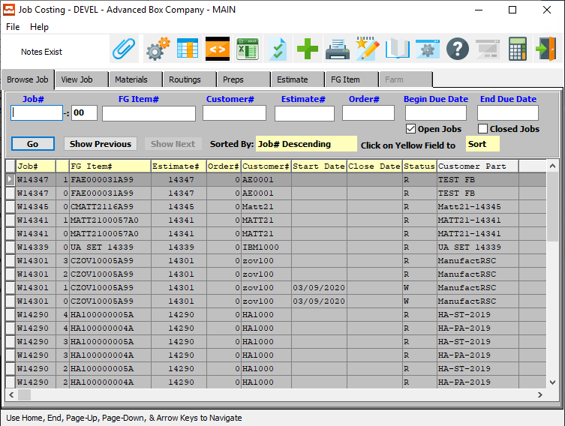

#### ADD

Click the ***“Green + Icon”*** to add a new Job.

### Browse Job Field Definitions

#### Job #

Enter the job number or you can do a ***“F1”*** look-up from list. A partial description may be typed into any field or data may be entered into multiple fields followed by pressing the ***“Go”*** button to sort the fields by the criteria that was entered. Once the data is presented on the screen, the YELLOW column heading may be clicked to sort that specific column in ascending or descending order.

#### Job #: 00

Enter the sequential starting/finishing number for the job.

#### FG Item #

Enter the FG item number or you may use the ***“F1”*** look-up. A partial description may be typed into any field or data may be entered into multiple fields followed by pressing the ***“Go”*** button to sort the fields by the criteria that was entered. Once the data is presented on the screen, the YELLOW column heading may be clicked to sort that specific column in ascending or descending order.

#### Customer #

Enter customer number or you may use the ***“F1”*** look-up. A partial description may be typed into any field or data may be entered into multiple fields followed by pressing the ***“Go”*** button to sort the fields by the criteria that was entered. Once the data is presented on the screen the YELLOW column heading may be clicked to sort that specific column in ascending or descending order.

#### Estimate #

Enter the estimate number or you may use the ***“F1”*** look-up. A partial description may be typed into any field or data may be entered into multiple fields followed by pressing the ***“Go”*** button to sort the fields by the criteria that was entered. Once the data is presented on the screen, the YELLOW column heading may be clicked to sort that specific column in ascending or descending order.

#### Order #

Enter order number or you may use the ***“F1”*** look-up. A partial description may be typed into any field or data may be entered into multiple fields followed by pressing the ***“Go”*** button to sort the fields by the criteria that was entered. Once the data is presented on the screen, the YELLOW column heading may be clicked to sort that specific column in ascending or descending order.

#### Begin Due date / End Due Date

Enter the starting and ending due date for the search.

#### Open Jobs – Toggle Box

To search Open Jobs, make sure that the Open Jobs toggle box is checked.

#### Close Jobs – Toggle Box

To search Closed Jobs, make sure that the Close Job toggle box is checked.

### View Job

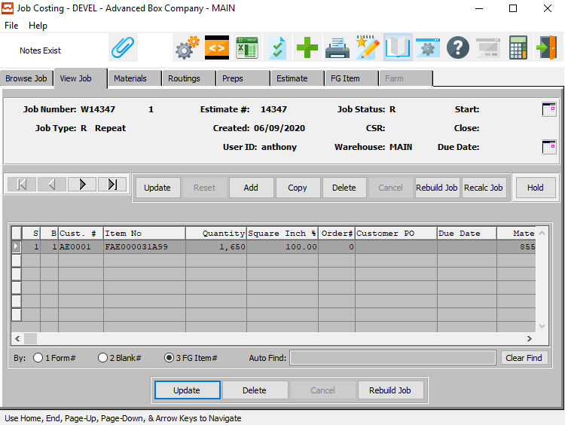

#### UPDATE

To change the currently selected job, simply click the ***“Update***” button at the middle of the screen.

#### ADD

To add a new job, simply click the ***“Green + Icon”*** button at the top of the Job Costing screen.

Alternatively, click the ***“Add”*** button in the middle of the screen.

#### COPY

Click the ***“Copy”*** button to copy information from the currently selected job.

#### DELETE

To delete the currently selected job, simply press the ***"D"*** key. Alternatively, click the ***“Delete”*** button In the middle of the screen.

#### REBUILD JOB

Click the ***“Rebuild Job”*** button after making any changes to the Materials or Routings tabs in order to rebuild both tabs and recalculate all Job Costs from the estimate standards.

#### RECALC JOB

Click the ***“Recalc Job”*** button to recalculate the Job Cost from the Job Standards with the Current Materials and Routing information.

#### HOLD

Click the ***“Hold”*** button to place the currently selected job on Hold. Once the button has been clicked, a new popup window will open, asking the user to choose a Rejection code pertaining to why the job is being placed on hold.

The Rejection Codes are user-defined in the File Maintenance for Jobs sections of the Job Costing program. If the user does not see an applicable Rejection Code, they may define a new one in the ‘Job Hold Reasons’ function.

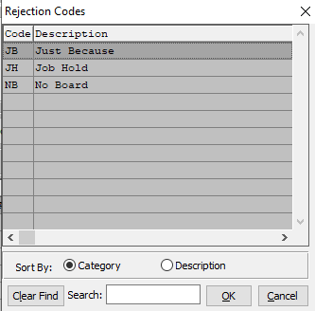

#### NEXT

Press ***"N"*** (Next) to find next job to view or modify. Alternatively, press the ***“Right Arrow”*** on the screen.

#### PREVIOUS

Press ***"P"*** (Previous) to find previous job to view or modify. Alternatively, press the ***“Left Arrow”*** on the screen.

#### UPDATE

To change the currently selected Job Item, simply click the ***“Update***” button at the bottom of the screen.

#### DELETE

To delete the currently selected Job Item, simply press the ***"D"*** key. Alternatively, click the ***“Delete”*** button at the bottom of the screen.

#### REBUILD JOB

Click the ***“Rebuild Job”*** button after making any changes to the Materials or Routings tabs in order to rebuild both tabs and recalculate all Job Costs from the estimate standards.

### Add/Update Job

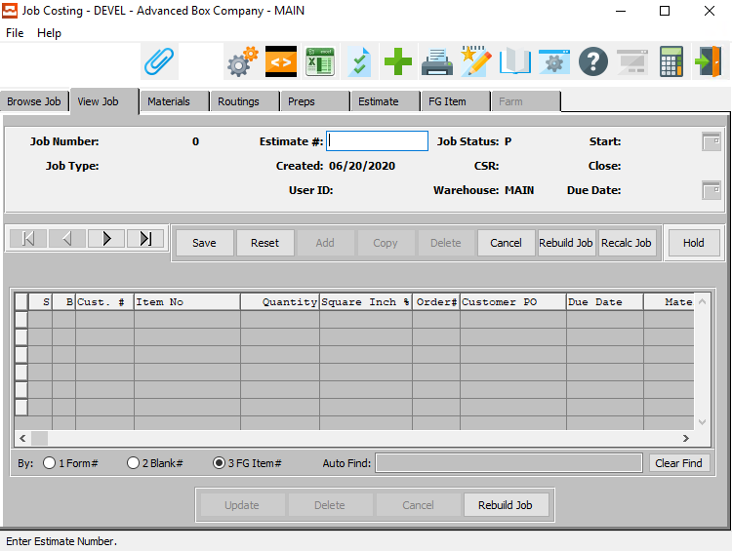

#### SAVE

Click the ***“Save”*** button to save all changes to the current Job.

#### RESET

Click the ***“Reset”*** button to reset all fields to their original state.

#### CANCEL

Click the ***“Cancel”*** button to cancel all changes to the Job without saving.

#### REBUILD JOB

Click the ***“Rebuild Job”*** button after making any changes to the Materials or Routings tabs in order to rebuild both tabs and recalculate all Job Costs from the estimate standards.

#### RECALC JOB

Click the ***“Recalc Job”*** button to recalculate the Job Cost from the Job Standards with the Current Materials and Routing information.

#### HOLD

Click the ***“Hold”*** button to place the currently selected job on Hold. Once the button has been clicked, a new popup window will open, asking the user to choose a Rejection code pertaining to why the job is being placed on hold.

The Rejection Codes are user-defined in the File Maintenance for Jobs sections of the Job Costing program. If the user does not see an applicable Rejection Code, they may define a new one in the ‘Job Hold Reasons’ function.



#### NEXT

Press ***"N"*** (Next) to find next Job to view or modify. Alternatively, press the ***“Right Arrow”*** on the screen.

#### PREVIOUS

Press ***"P"*** (Previous) to find previous Job to view or modify. Alternatively, press the ***“Left Arrow”*** on the screen.

#### Estimate #

The estimate number is automatically assigned in estimating and is required for a job number. All of the details for making a box must be defined in Estimating, however, changes may be made in the Job Standards file prior to producing the item.

### Update Job Items

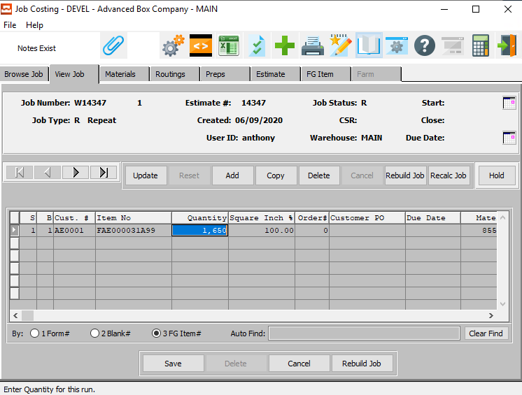

#### SAVE

Click the ***“Save”*** button to save all changes to the current Job Item.

#### CANCEL

Click the ***“Cancel”*** button to cancel all changes to the Job Item without saving.

#### REBUILD JOB

Click the ***“Rebuild Job”*** button after making any changes to the Materials or Routings tabs in order to rebuild both tabs and recalculate all Job Costs from the estimate standards.

### Update Job Items Field Definitions

#### Quantity

The job quantity is the total quantity required when producing this item.

#### Order #

The order number(s) are valid numbers in the order entry system. Multiple order numbers may be assigned to one job number. For example, if multiple orders are entered for single item boxes then later combined for a combination order there would exist one job number but multiple order numbers.

### Materials

All of the materials estimated for the job will automatically transfer to the Job Standards Materials screen to be used for comparison against actual costs which are issued to the job via Production Control. Materials may be added, changed, or deleted as the Production Planning Manager requires. It may be required to change material codes. Particularly if the material codes transferred from Estimating are estimated materials costed on a standard basis.

For example, we may estimate an SBS 18-point board. However, we may go buy a stocked roll or sheet which is the item which we will maintain a perpetual inventory for in the Raw Materials file. The posting status code for each material labeled as ***"P"*** identifies whether the items standard cost is posted as the actual cost for Job Costing. If the flag is set to *‘Yes’*, as defined in the Job Costing control file, then no Production Control posting is required to post this material to the job.

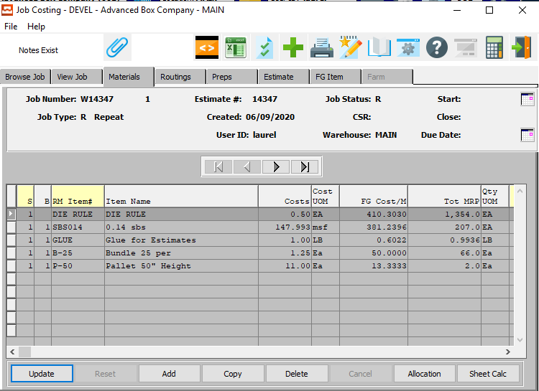

#### UPDATE

To change the currently selected Material, simply click the ***“Update***” button at the bottom of the screen.

#### ADD

Click the ***“Add”*** button to add a new Material.

#### COPY

Click the ***“Copy”*** button to copy information from the currently selected Material.

#### DELETE

To delete the currently selected Material, simply press the ***"D"*** key. Alternatively, click the ***“Delete”*** button at the bottom of the screen.

#### ALLOCATION

Click the ***“Allocation”*** button to allocate the currently selected job item.

Please Note: If the Job Status is currently on Hold, the user will be asked to verify if they wish to continue with the allocation of the item.

#### SHEET CALC

This button allows selecting of stock rolls and sheets. Click the ***“Sheet Calc”*** button in the job file to select a stocked sheet or a stocked roll size to issue to the production floor.

Please Note: The ***“Sheet Calculation”*** button must be pressed for each form.

#### NEXT

Press ***"N"*** (Next) to find next Material to view or modify. Alternatively, press the ***“Right Arrow”*** on the screen.

#### PREVIOUS

Press ***"P"*** (Previous) to find previous Material to view or modify. Alternatively, press the ***“Left Arrow”*** on the screen.

### Add/Update Materials

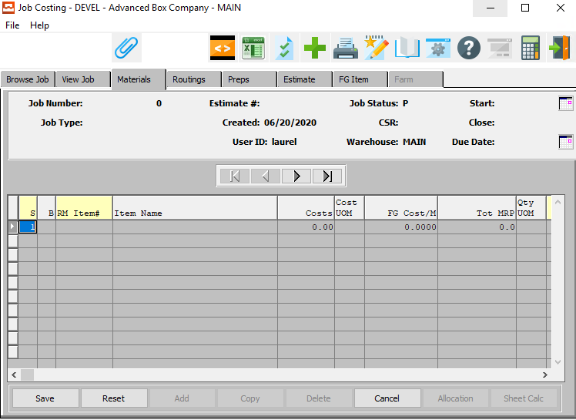

#### SAVE

Click the ***“Save”*** button to save all changes to the current Material.

#### RESET

Click the ***“Reset”*** button to reset all fields to their original state.

#### CANCEL

Click the ***“Cancel”*** button to cancel all changes to the Material without saving.

### Add/Update Materials Field Definitions

#### S

The sheet or form field dictates which form the items costs will be applied to. This field is necessary because certain combination jobs may have more than one sheet size defined.

#### B

The Blank field defines the cost to be applied to a specific item on the job. If the blank field is 00 then the material cost will be applied on a square inch basis for all items on the estimate. If the blank field is defined for a particular item, the material cost will only be applied for that item.

#### RM Item #

The raw materials item number which was defined on the estimate will transfer automatically to this field.

#### Item Name

The Item Name transfers from the Item file when the user enters or chooses a valid RM Item Number.

#### Costs

The cost of the item will transfer from the item file when the user enters or chooses a valid RM Item Number. However, this can be modified by the user here, if necessary.

#### Cost UOM

The sell price unit of measure defaults to M for per thousand, however this may be modified. Each unit of measure will yield a different total selling price.

Valid Units of Measure are:

|  |  |
| --- | --- |
| C | Per Hundred |
| CS | Per Case |
| EA | Per Each |
| L | Per Lot |
| M | Per Thousand |

#### FG Cost/M

The cost per 1000 is the calculated cost per thousand items. This cost may be used to calculate variances when receipts to Finished Goods are received.

#### Tot MRP

This is the material requirements planned for that item to make the necessary quantity of items for the job. The material requirements may be used by the purchasing agent to buy materials for the job.

#### Qty UOM

The sell price unit of measure defaults to M for per thousand, however this may be modified. Each unit of measure will yield a different total selling price.

Valid Units of Measure are:

|  |  |
| --- | --- |
| C | Per Hundred |
| CS | Per Case |
| EA | Per Each |
| L | Per Lot |
| M | Per Thousand |

#### Width

Only the sheet width or roll width will be defined here for board material or any other sub-straight used on the job.

#### Length

The calculated length for the job will default here for board material.

#### #Up

The number up field will transfer automatically from the estimate for the layout on the board material.

#### MSF Weight

The basis weight or wt. per 1000 sq. ft. will transfer automatically from the Raw Materials files for the board material estimated for this job.

#### Auto Post?

This is a *“Yes”* or *“No”* field. The post field is used to dictate automatic posting the material cost at standard to the job. This will be used to save data entry time of issuing actual costs for materials which may be deemed insignificant such as ink or glue.

If a *“Yes”* flag is indicated to automatically post the cost, it will be transferred into the Width cost when closing the job. All other materials which are not automatically posted must be issued to the job during production posting.

### Routings Overview

The Routing screen defines all of the machines listed to produce the item(s) for the job. All of the standard Make Ready Hours, Make Ready Waste, Run Hours, Run Speed, and Run Spoilage defined in the Routing standards file will be used to calculate Routing variances against actual hours, quantities and waste posted during production control.

The Make Ready Hours and Make Ready Waste listed on the Standards Routing screen will be compared against the actual make ready and actual waste posted during production control. Hence, the system will calculate a variance for both Make Ready Hours and Make Ready Waste.

The Run Speed defined in the Standards Routing screen will be used to calculate the standard run hours based on the actual hours posted along with the actual quantity posted whereby the quantity posted is divided by the standard run speed to yield standard run hours which is compared to the actual run hours to yield a run hour variance as well as a run speed variance. The waste posted during production running will be compared to the standard waste percentage to yield a run spoilage variance.

Please Note: The machine rates are broken down between direct labor which includes the crew size, fixed overhead and variable overhead. For each hour posted through production the hour is multiplied by each rate factor so that efficiency variances are recorded for direct labor, fixed overhead, and variable overhead.

Machines may be added, changed, or deleted as the production scheduling manager dictates.

### Routings Screen

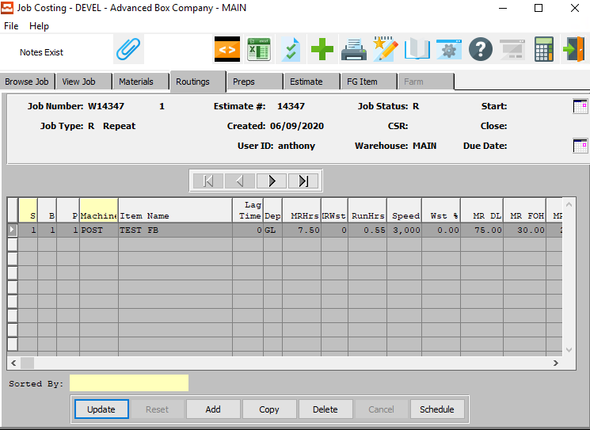

#### UPDATE

To change the currently selected Routing, simply click the ***“Update***” button at the bottom of the screen.

#### ADD

Click the ***“Add”*** button to add a new Routing.

#### COPY

Click the ***“Copy”*** button to copy information from the currently selected Routing.

#### DELETE

To delete the currently selected Routing, simply press the ***"D"*** key. Alternatively, click the ***“Delete”*** button at the bottom of the screen.

#### SCHEDULE

Click the ***“Schedule”*** button to bring up the machine scheduling screen for the current job routing.

#### NEXT

Press ***"N"*** (Next) to find next Routing to view or modify. Alternatively, press the ***“Right Arrow”*** on the screen.

#### PREVIOUS

Press ***"P"*** (Previous) to find previous Routing to view or modify. Alternatively, press the ***“Left Arrow”*** on the screen.

### Routings Schedule

To add a Machine to the capacity schedule, the user may use their mouse to double-click on the desired Machine in the Machine/Description column on the left side of the screen. Once a new machine is double-clicked, it will appear in the Job list on the right side of the screen.

Machines on the right side of the screen may be further sorted or modified according to the user’s needs.

For each chosen Machine, the user may modify the Number of Forms, Number of Blanks, Number of Passes, Machine Rate Hour, Machine Run Hour

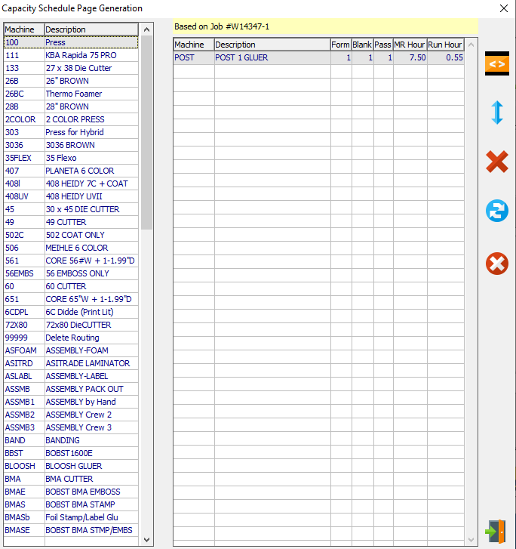

#### GENERATE PAGE

Click the ***“Orange < > Box Icon”*** button to generate a schedule based on all machines for the current job.

#### SORT

Click the ***“Blue Up and Down Arrow Icon”*** button to sort the Machine Schedule list.

#### REMOVE

The user may remove a selected machine at any time. To do so, click on the desired machine to be deleted to highlight it within the list. Once the desired machine is highlighted, click on the ***“Red X Icon”*** button at the right of the screen to remove the selected machine from the machine list.

#### RESET

Click the ***“Blue Refresh Arrows Icon”*** button to reset all changes to the current Schedule.

#### CLEAR

Click the ***“Red Circle with White X Icon”*** button to clear all Machine from the Machine List, including entries made before the current modifications.

#### EXIT

Click the ***“Exit Door Icon”*** to exit the Machine Capacity Schedule popup screen.

### Add/Update Routings

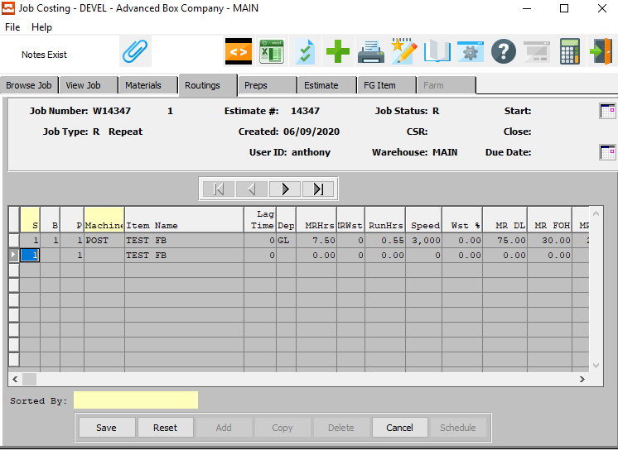

#### SAVE

Click the ***“Save”*** button to save all changes to the current Routing.

#### RESET

Click the ***“Reset”*** button to reset all fields to their original state.

#### CANCEL

Click the ***“Cancel”*** button to cancel all changes to the Routing without saving.

### Add/Update Routings Field Definitions

#### S

The sheet or form field dictates which form the items costs will be applied to. This field is necessary because certain combination jobs may have more than one sheet size defined.

#### B

The Blank field defines the cost to be applied to a specific item on the job. If the blank field is 00 then the material cost will be applied on a square inch basis for all items on the estimate. If the blank field is defined for a particular item, the material cost will only be applied for that item.

#### P

The pass field indicates the pass for the printing press.

#### Machine

The operation or machine code defines the machine ID's which will default from the machine file.

#### Item Name

The item name will only be defined when the routing operation is applied to only that item. This will always be the case for one item on the job, however, if multiple items as in the case of a combination run are defined in a job then the item name would not be defined for the common operations. For finishing operations, the item name will be identified.

#### Dep

The department will transfer automatically for the machine ID from the machine file.

#### MR Hours

The standard Make Ready Hours transfer from the estimate automatically for each machine on the job.

#### MR Waste

The make ready waste will be automatically transferred for each operation for the job. The waste will be either in sheets or blanks depending on the machine.

#### Run Hours

The total estimated run hours will be calculated and transferred to the Machine Standards file. The run hours may be modified by changing the machine on the routing screen. That is if the machine which will be used to produce the item is different from the machine estimated, the standards will be searched in the machine file for the actual machine scheduled for production. In this case, the new run hours will be calculated.

#### Speed

The estimated run speed for each machine will transfer automatically once calculated by the estimating procedures when creating a job. The speed may be modified by changing the machine on the routing screen.

That is if the machine which will be used to produce the item is different from the machine estimated, the standards will be searched in the machine file for the actual machine scheduled for production. In this case, the new speed will be calculated.

#### Waste %

The run spoilage percentage will transfer automatically for each machine on the job. The waste % may be modified by changing the machine on the routing screen.

That is if the machine which will be used to produce the item is different from the machine estimated, the standards will be searched in the machine file for the actual machine scheduled for production. In this case, the new waste % will be calculated.

#### MR DL

The direct labor rate will transfer from the machine file for each machine on the job. The direct labor may be modified by changing the machine on the routing screen.

That is if the machine which will be used to produce the item is different from the machine estimated, the standards will be searched in the machine file for the actual machine scheduled for production. In this case, the new direct labor will be calculated.

#### MR Fixed Overhead

The fixed overhead rate will transfer from the machine file for each machine on the job. The fixed overhead may be modified by changing the machine on the routing screen.

That is if the machine which will be used to produce the item is different from the machine estimated, the standards will be searched in the machine file for the actual machine scheduled for production. In this case, the new fixed overhead will be calculated.

#### MR Variable Overhead

The variable overhead rate will transfer from the machine file for each machine on the job. The variable overhead may be modified by changing the machine on the routing screen.

That is if the machine which will be used to produce the item is different from the machine estimated, the standards will be searched in the machine file for the actual machine scheduled for production. In this case, the new variable overhead will be calculated.

#### Start Time / End Time

Enter the beginning and ending Routing Time to run the report for.

### Preps Overview

Preparation labor and materials such as plates, dies, and graphics may be transferred to the estimate automatically if defined in the Prep File. You have the option to include prep costs within direct factory cost, within full cost or to bill separately. In addition, you may mark this cost up by any percentage.

All prep charges automatically transferred from the prep file may be modified. Qty refers to the total quantity for this prep charge. The costing unit of measure which applies to this quantity is defined in the prep file. For example, for labor charges qty would equal the number of hours required whereas the quantity of plates is individual.

Please Note: Currently the total quaintly is only calculated for die inches if defined in the style file box formula and die square inches for board cost. All other prep charges require manually entering the total prep required.

### Preps Screen

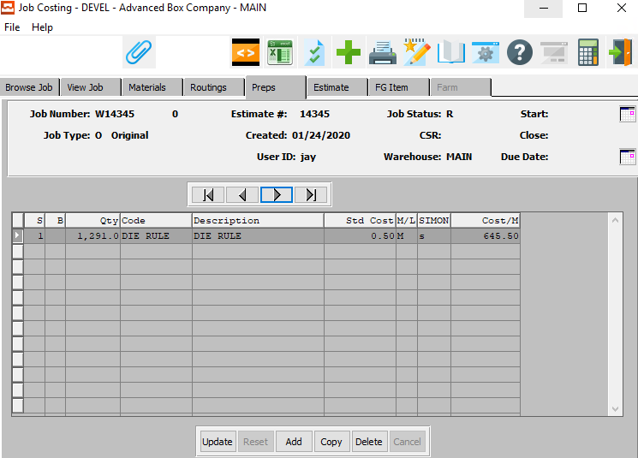

#### UPDATE

To change the currently selected Preparation, simply click the ***“Update***” button at the bottom of the screen.

#### ADD

Click the ***“Add”*** button to add a new Preparation.

#### COPY

Click the ***“Copy”*** button to copy information from the currently selected Preparation.

#### DELETE

To delete the currently selected Preparation, simply press the ***"D"*** key. Alternatively, click the ***“Delete”*** button at the bottom of the screen.

#### NEXT

Press ***"N"*** (Next) to find next Preparation to view or modify. Alternatively, press the ***“Right Arrow”*** on the screen.

#### PREVIOUS

Press ***"P"*** (Previous) to find previous Preparation to view or modify. Alternatively, press the ***“Left Arrow”*** on the screen.

### Add Prep

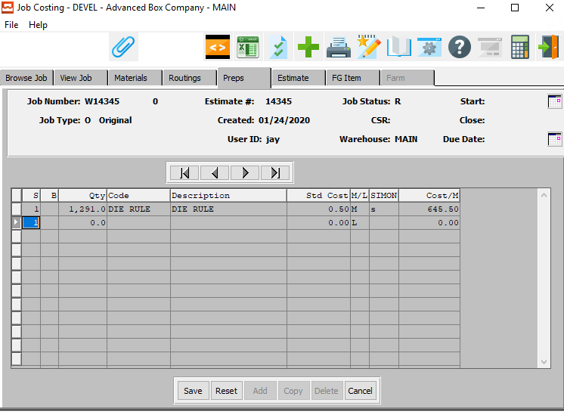

#### SAVE

Click the ***“Save”*** button to save all changes to the current Preparation.

#### RESET

Click the ***“Reset”*** button to reset all fields to their original state.

#### CANCEL

Click the ***“Cancel”*** button to cancel all changes to the Preparation without saving.

### Add Prep Field Definitions

#### S

The sheet or form field dictates which form the items costs will be applied to. This field is necessary because certain combination jobs may have more than one sheet size defined.

#### B

The Blank field defines the cost to be applied to a specific item on the job. If the blank field is 00 then the material cost will be applied on a square inch basis for all items on the estimate. If the blank field is defined for a particular item, the material cost will only be applied for that item.

#### Quantity

Enter the quantity of graphics or prep materials required for this estimate. The total number of hours or total quantity of plates must be manually entered.

#### Code

Enter the cost type for this prep charge.

#### Description

The prep description will transfer from the prep file once the user has entered or chosen a valid prep code.

#### Standard Cost

The standard cost as estimated for this item will transfer automatically and will be used later to calculate purchase price variances against the actual cost issued to the job.

#### M/L

Valid entries are ***"M"*** for Material charge and ***"L"*** for Labor charge. This field dictates which burden percentage from the control file to utilize for calculating the GS & A cost.

#### SIMON

(1) alpha character. Valid entries are as follows:

|  |  |
| --- | --- |
| S | Indicates that this preparation charge should be billed separately, marked up by the percentage entered and excluded from all costs used to calculate the selling price. |
| I | Indicates this is for integrating the cost as part of direct factory cost, which is marked up by the GS&A burden rate in the control file. |
| M | For maintenance charge, which is included in direct factory cost and marked up by the percentage, which transfers from the prep file. |
| O | For other markup, which is excluded from factory cost, but added to the full cost after the normal GS&A and profit percentages are calculated. |
| N | This stands for No Charge and No Cost. Hence, this is strictly information for the factory. |

#### Cost/M

Enter the cost per thousand.

### Estimate Screen

Clicking the ***Estimate*** tab will bring up a popup screen of the Estimation system.

To learn more about how the ***Estimating*** system works, please refer to the “Corrugated” or “Folding” Estimating Manuals.

### FG Item

Clicking the ***FG Item*** tab will bring up a popup screen of the Finished Goods system.

To learn more about how the ***Finished Goods*** system works, please refer to the “Finished Goods” Manual.

## Approve Jobs [JU2]

### Browse Jobs

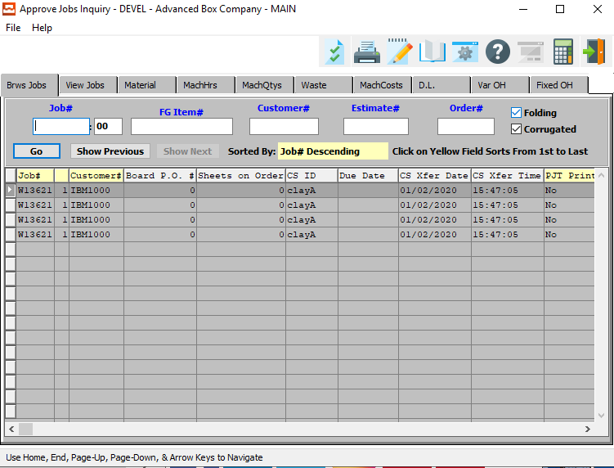

### Browse Jobs Field Definitions

#### Job #

Enter the job number or you can do a ***“F1”*** look-up from list. A partial description may be typed into any field or data may be entered into multiple fields followed by pressing the ***“Go”*** button to sort the fields by the criteria that was entered. Once the data is presented on the screen, the YELLOW column heading may be clicked to sort that specific column in ascending or descending order.

#### Job #: 00

Enter the sequential starting/finishing number for the job.

#### FG Item #

Enter the FG item number or you may use the ***“F1”*** look-up. A partial description may be typed into any field or data may be entered into multiple fields followed by pressing the ***“Go”*** button to sort the fields by the criteria that was entered. Once the data is presented on the screen, the YELLOW column heading may be clicked to sort that specific column in ascending or descending order.

#### Customer #

Enter customer number or you may use the ***“F1”*** look-up. A partial description may be typed into any field or data may be entered into multiple fields followed by pressing the ***“Go”*** button to sort the fields by the criteria that was entered. Once the data is presented on the screen the YELLOW column heading may be clicked to sort that specific column in ascending or descending order.

#### Estimate #

Enter the estimate number or you may use the ***“F1”*** look-up. A partial description may be typed into any field or data may be entered into multiple fields followed by pressing the ***“Go”*** button to sort the fields by the criteria that was entered. Once the data is presented on the screen, the YELLOW column heading may be clicked to sort that specific column in ascending or descending order.

#### Order #

Enter order number or you may use the ***“F1”*** look-up. A partial description may be typed into any field or data may be entered into multiple fields followed by pressing the ***“Go”*** button to sort the fields by the criteria that was entered. Once the data is presented on the screen, the YELLOW column heading may be clicked to sort that specific column in ascending or descending order.

#### Folding – Toggle Box

To Search for jobs with Folding Boxes, make sure that the Folding toggle box is checked.

#### Corrugated – Toggle Box

To search for jobs with Corrugated Boxes, make sure that the Corrugated toggle box is checked.

### View Jobs

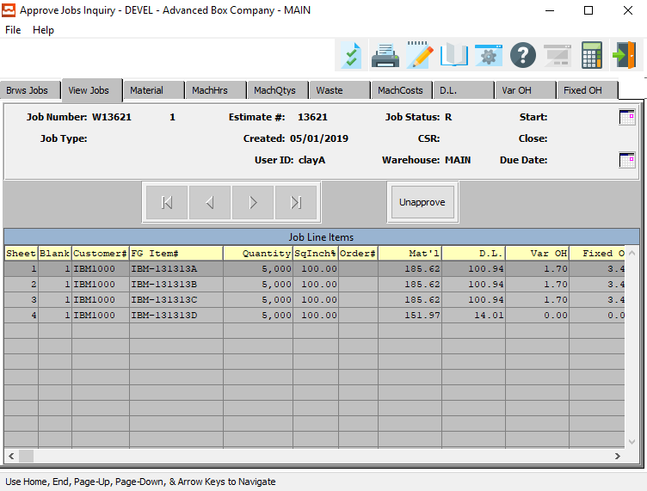

#### UNAPPROVE

Click the ***“Unapprove”*** button to mark the currently selected job as unapproved.

### Material

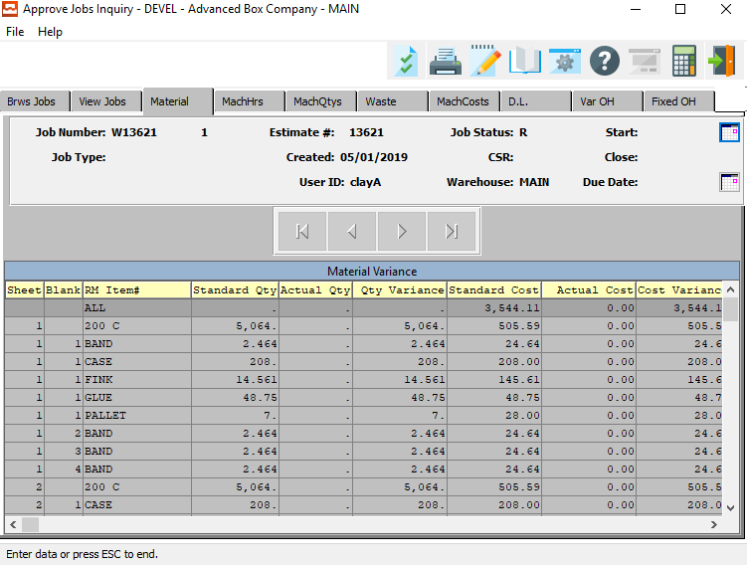

### Machine Hours

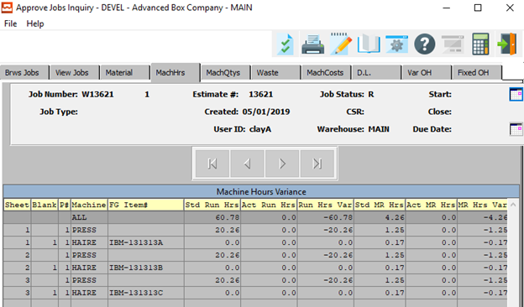

### Machine Qtys

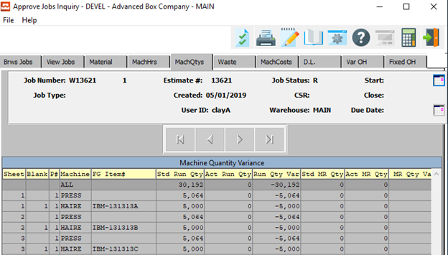

### Waste

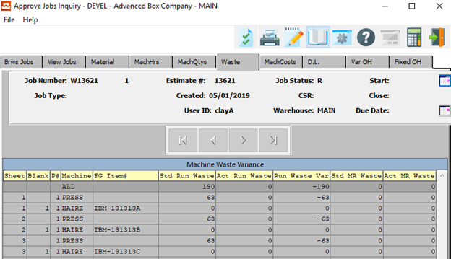

### Machine Costs

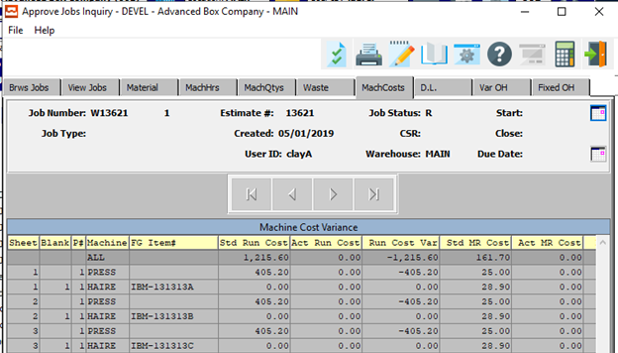

### D.L.

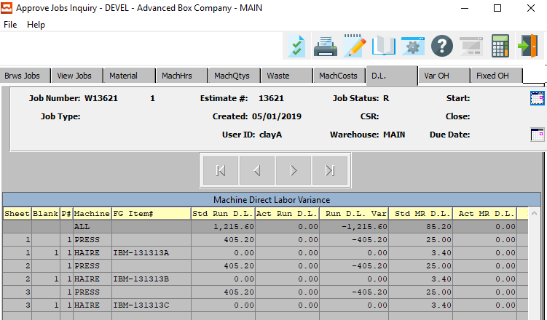

### Variable Overhead

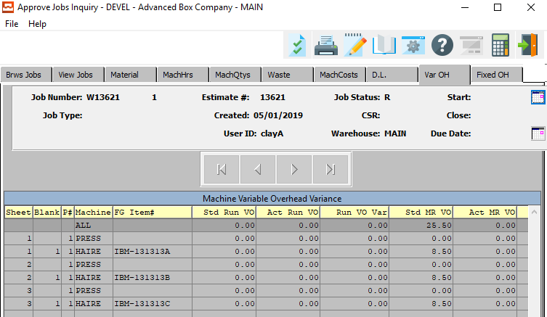

### Fixed Overhead

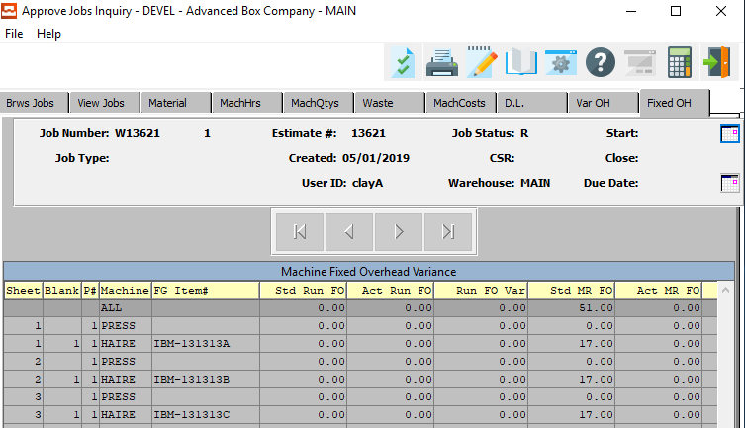

## CorrTrim Downloading Program [JU5]

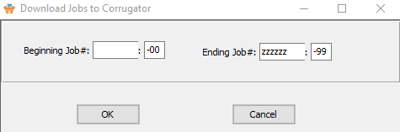

#### Beginning Job # / Ending Job #

Enter the first and last job number to be included in this report.

## CorrTrim Downloading Inquiry [JU6]

### Browse History

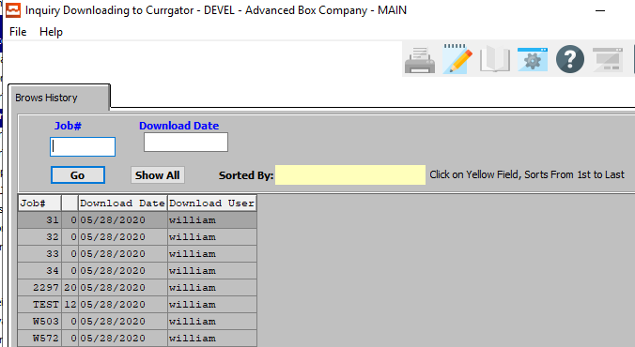

#### Job #

Enter the job number or you can do a ***“F1”*** look-up from list. A partial description may be typed into any field or data may be entered into multiple fields followed by pressing the ***“Go”*** button to sort the fields by the criteria that was entered. Once the data is presented on the screen, the YELLOW column heading may be clicked to sort that specific column in ascending or descending order.

#### Download Date

Enter the download date of a file you wish to search for.

## CorrTrim Uploading Program [JU7]

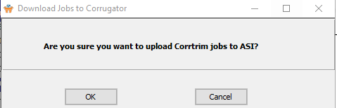

## CorrTrim Uploading History Inquiry [JU8]

### Browse History

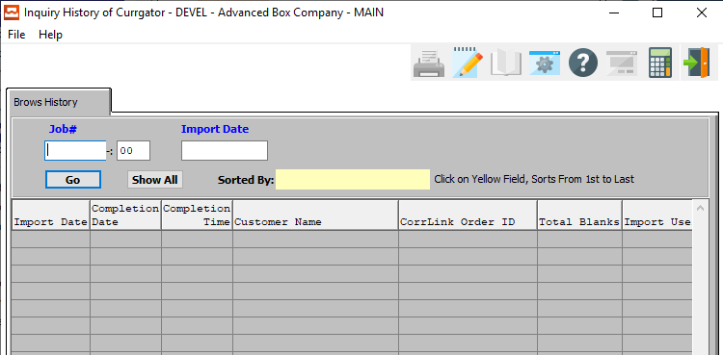

#### Job #

Enter the job number or you can do a ***“F1”*** look-up from list. A partial description may be typed into any field or data may be entered into multiple fields followed by pressing the ***“Go”*** button to sort the fields by the criteria that was entered. Once the data is presented on the screen, the YELLOW column heading may be clicked to sort that specific column in ascending or descending order.

#### Job #: 00

Enter the sequential starting/finishing number for the job.

#### Import Date

Enter the import date of the history to search for.

# **Close/Reopen Jobs [JC]**

## Overview

The Close/Reopen Job process will reopen jobs which have been closed. This will allow additional labor or material costs to be added to the job. Once complete, the job must be reclosed. When the job is closed again, the closing job variances for this job to reflect the new material and/or labor costs.

The purpose of closing a job is to trigger the Job Costing system to balance the General Ledger accounts created for the job so that closing job variances have been calculated.

To close a job simply press the ***"C"*** for close key. To reopen a closed job, press the ***"E"*** key for reopen. To review any of the details of this job prior to opening or closing, you may look at the line items, materials, machine routing, and the waste. These have been applied previously to the job.

## Browse Jobs

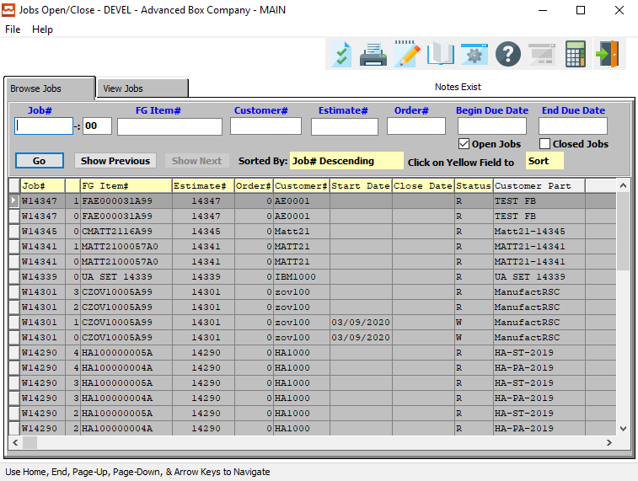

### Browse Jobs Field Definitions

#### Job #

Enter the job number or you can do a ***“F1”*** look-up from list. A partial description may be typed into any field or data may be entered into multiple fields followed by pressing the ***“Go”*** button to sort the fields by the criteria that was entered. Once the data is presented on the screen, the YELLOW column heading may be clicked to sort that specific column in ascending or descending order.

#### Job #: 00

Enter the sequential starting/finishing number for the job.

#### FG Item #

Enter the FG item number or you may use the ***“F1”*** look-up. A partial description may be typed into any field or data may be entered into multiple fields followed by pressing the ***“Go”*** button to sort the fields by the criteria that was entered. Once the data is presented on the screen, the YELLOW column heading may be clicked to sort that specific column in ascending or descending order.

#### Customer #

Enter customer number or you may use the ***“F1”*** look-up. A partial description may be typed into any field or data may be entered into multiple fields followed by pressing the ***“Go”*** button to sort the fields by the criteria that was entered. Once the data is presented on the screen the YELLOW column heading may be clicked to sort that specific column in ascending or descending order.

#### Estimate #

Enter the estimate number or you may use the ***“F1”*** look-up. A partial description may be typed into any field or data may be entered into multiple fields followed by pressing the ***“Go”*** button to sort the fields by the criteria that was entered. Once the data is presented on the screen, the YELLOW column heading may be clicked to sort that specific column in ascending or descending order.

#### Order #

Enter order number or you may use the ***“F1”*** look-up. A partial description may be typed into any field or data may be entered into multiple fields followed by pressing the ***“Go”*** button to sort the fields by the criteria that was entered. Once the data is presented on the screen, the YELLOW column heading may be clicked to sort that specific column in ascending or descending order.

#### Begin Due date / End Due Date

Enter the starting and ending due date for the search.

#### Open Jobs – Toggle Box

To search Open Jobs, make sure that the Open Jobs toggle box is checked.

#### Close Jobs – Toggle Box

To search Closed Jobs, make sure that the Close Job toggle box is checked.

## View Jobs

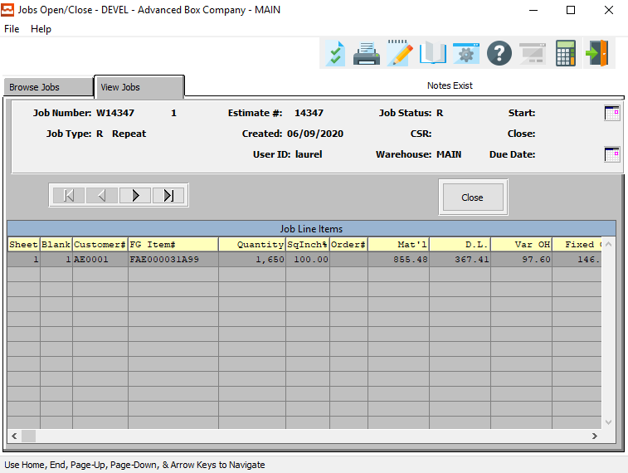

#### NEXT

Press ***"N"*** (Next) to find next Job to view or modify. Alternatively, press the ***“Right Arrow”*** on the screen.

#### PREVIOUS

Press ***"P"*** (Previous) to find previous Job to view or modify. Alternatively, press the ***“Left Arrow”*** on the screen.

#### CLOSE

Click the ***“Close”*** button to close the current Job.

# **Query Jobs [JQ]**

## Job Variance [JQ1]

The Inquiries provide up to date information on cost variances and production variances by material cost, labor cost, labor hours and production quantities for each job and each machine within a job.

### Browse Jobs

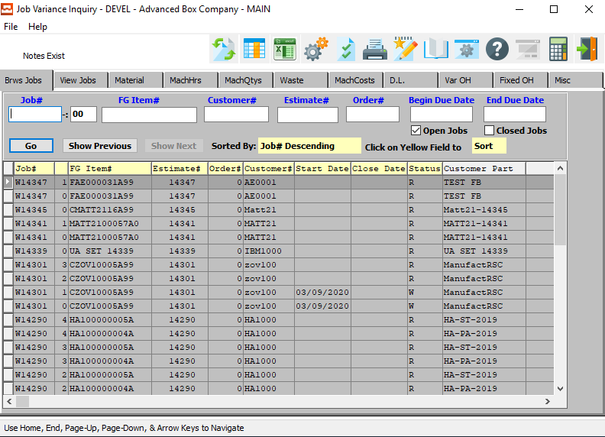

#### Job #

Enter the job number or you can do a ***“F1”*** look-up from list. A partial description may be typed into any field or data may be entered into multiple fields followed by pressing the ***“Go”*** button to sort the fields by the criteria that was entered. Once the data is presented on the screen, the YELLOW column heading may be clicked to sort that specific column in ascending or descending order.

#### Job #: 00

Enter the sequential starting/finishing number for the job.

#### FG Item #

Enter the FG item number or you may use the ***“F1”*** look-up. A partial description may be typed into any field or data may be entered into multiple fields followed by pressing the ***“Go”*** button to sort the fields by the criteria that was entered. Once the data is presented on the screen, the YELLOW column heading may be clicked to sort that specific column in ascending or descending order.

#### Customer #

Enter customer number or you may use the ***“F1”*** look-up. A partial description may be typed into any field or data may be entered into multiple fields followed by pressing the ***“Go”*** button to sort the fields by the criteria that was entered. Once the data is presented on the screen the YELLOW column heading may be clicked to sort that specific column in ascending or descending order.

#### Estimate #

Enter the estimate number or you may use the ***“F1”*** look-up. A partial description may be typed into any field or data may be entered into multiple fields followed by pressing the ***“Go”*** button to sort the fields by the criteria that was entered. Once the data is presented on the screen, the YELLOW column heading may be clicked to sort that specific column in ascending or descending order.

#### Order #

Enter order number or you may use the ***“F1”*** look-up. A partial description may be typed into any field or data may be entered into multiple fields followed by pressing the ***“Go”*** button to sort the fields by the criteria that was entered. Once the data is presented on the screen, the YELLOW column heading may be clicked to sort that specific column in ascending or descending order.

#### Begin Due date / End Due Date

Enter the starting and ending due date for the search.

#### Open Jobs – Toggle Box

To search Open Jobs, make sure that the Open Jobs toggle box is checked.

#### Close Jobs – Toggle Box

To search Closed Jobs, make sure that the Close Job toggle box is checked.

### View Jobs

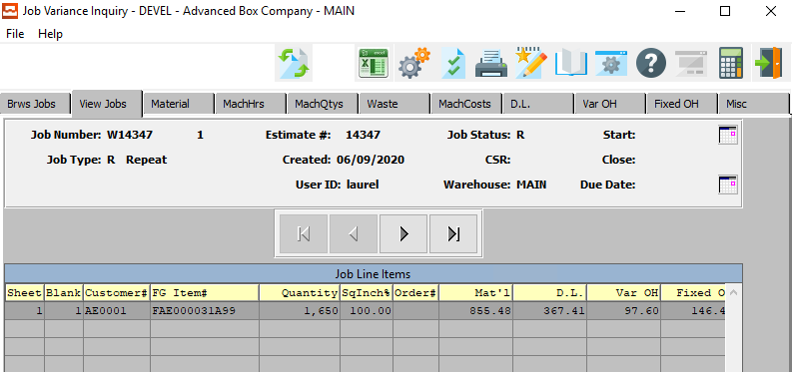

#### NEXT

Press ***"N"*** (Next) to find next Job to view. Alternatively, press the ***“Right Arrow”*** on the screen.

#### PREVIOUS

Press ***"P"*** (Previous) to find previous Job to view. Alternatively, press the ***“Left Arrow”*** on the screen.

### Material

By pressing the ***"M"*** key for materials, a list for all materials that was transferred to the job will be displayed showing each form and blank with all of the associated materials with the actual standard costs, quantities and costs, and the associated variance.

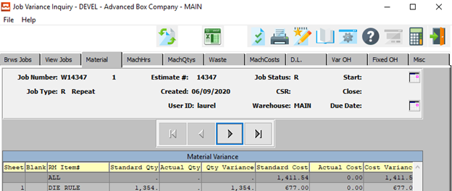

#### NEXT

Press ***"N"*** (Next) to find next Material to view. Alternatively, press the ***“Right Arrow”*** on the screen.

#### PREVIOUS

Press ***"P"*** (Previous) to find previous Material to view. Alternatively, press the ***“Left Arrow”*** on the screen.

### Machine Hours

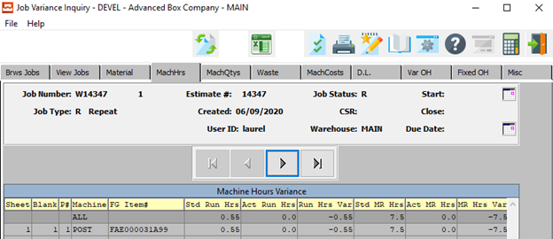

#### NEXT

Press ***"N"*** (Next) to find next Machine Hours report to view. Alternatively, press the ***“Right Arrow”*** on the screen.

#### PREVIOUS

Press ***"P"*** (Previous) to find previous Machine Hours report to view. Alternatively, press the ***“Left Arrow”*** on the screen.

### Machine Qtys

This Inquiry shows the quantities produced for each machine for each form and each blank showing the totals standard and actual quantities produced and make ready quantities along with their associated variances.

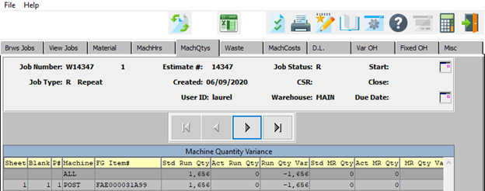

#### NEXT

Press ***"N"*** (Next) to find next Machine Quantity report to view. Alternatively, press the ***“Right Arrow”*** on the screen.

#### PREVIOUS

Press ***"P"*** (Previous) to find previous Machine Quantity report to view. Alternatively, press the ***“Left Arrow”*** on the screen.

### Waste

This shows the make ready waste and run spoilage waste for each machine on the job for the form and blank showing the estimated versus actual and the variance.

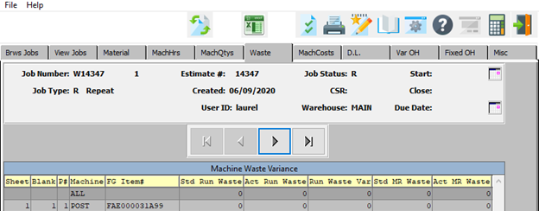

#### NEXT

Press ***"N"*** (Next) to find next Waste report to view. Alternatively, press the ***“Right Arrow”*** on the screen.

#### PREVIOUS

Press ***"P"*** (Previous) to find previous Waste report to view. Alternatively, press the ***“Left Arrow”*** on the screen.

### Machine Costs

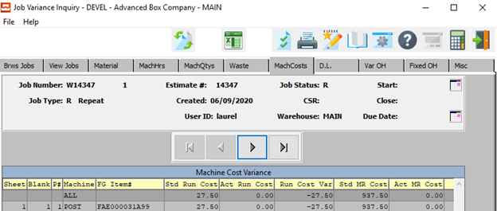

#### NEXT

Press ***"N"*** (Next) to find next Machine Cost report to view. Alternatively, press the ***“Right Arrow”*** on the screen.

#### PREVIOUS

Press ***"P"*** (Previous) to find previous Machine Cost report to view. Alternatively, press the ***“Left Arrow”*** on the screen.

### D.L.

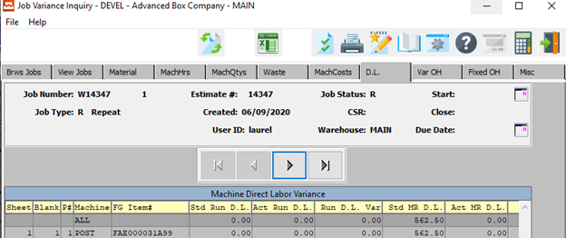

#### NEXT

Press ***"N"*** (Next) to find next D.L. report to view. Alternatively, press the ***“Right Arrow”*** on the screen.

#### PREVIOUS

Press ***"P"*** (Previous) to find previous D.L. report to view. Alternatively, press the ***“Left Arrow”*** on the screen.

### Variable Overhead

This screen shows the variable overhead cost for each machine on the job showing the standard, actual, and variance for make-ready and run as a result of variable overhead associated to that machine.

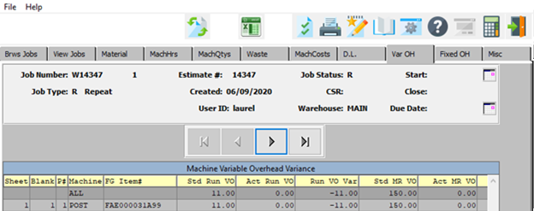

#### NEXT

Press ***"N"*** (Next) to find next Variable Overhead report to view. Alternatively, press the ***“Right Arrow”*** on the screen.

#### PREVIOUS

Press ***"P"*** (Previous) to find previous Variable Overhead report to view. Alternatively, press the ***“Left Arrow”*** on the screen.

### Fixed Overhead

This screen shows the fixed overhead cost for each machine on the job showing the standard, actual, and variance for make-ready and run as a result of fixed overhead associated to that machine.

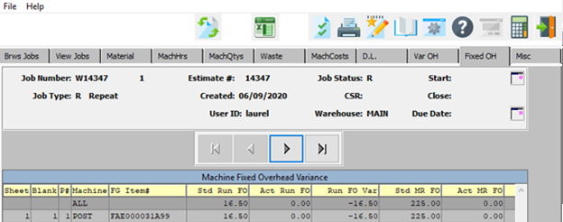

#### NEXT

Press ***"N"*** (Next) to find next Fixed Overhead report to view. Alternatively, press the ***“Right Arrow”*** on the screen.

#### PREVIOUS

Press ***"P"*** (Previous) to find previous Fixed Overhead report to view. Alternatively, press the ***“Left Arrow”*** on the screen.

### Miscellaneous

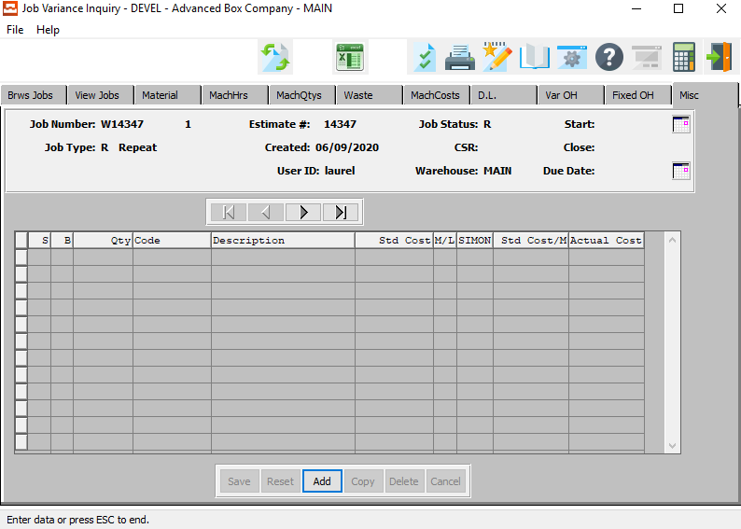

#### NEXT

Press ***"N"*** (Next) to find next Miscellaneous report to view. Alternatively, press the ***“Right Arrow”*** on the screen.

#### PREVIOUS

Press ***"P"*** (Previous) to find previous Miscellaneous report to view. Alternatively, press the ***“Left Arrow”*** on the screen.

#### ADD

Click the ***“Add”*** button to add a new Miscellaneous Cost.

### Add Miscellaneous

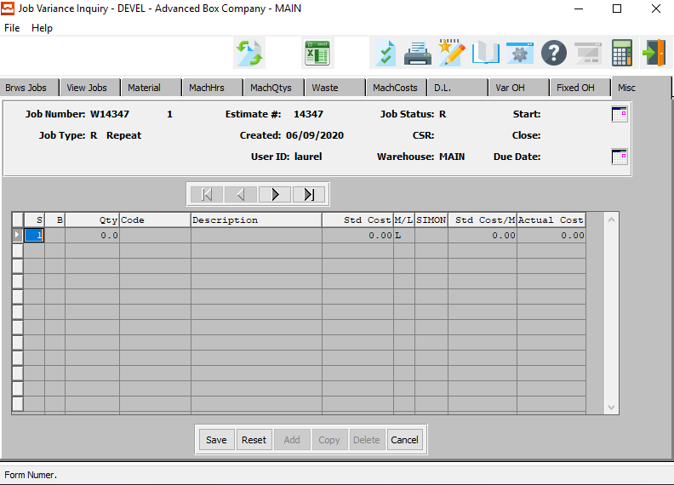

#### SAVE

Click the ***“Save”*** button to save all changes to the current Miscellaneous Cost.

#### RESET

Click the ***“Reset”*** button to reset all fields to their original state.

#### CANCEL

Click the ***“Cancel”*** button to cancel all changes to the Miscellaneous Cost without saving.

### Add Miscellaneous Field Definitions

#### S

The sheet or form field dictates which form the items costs will be applied to. This field is necessary because certain combination jobs may have more than one sheet size defined.

#### B

The Blank field defines the cost to be applied to a specific item on the job. If the blank field is 00 then the material cost will be applied on a square inch basis for all items on the estimate. If the blank field is defined for a particular item, the material cost will only be applied for that item.

#### Quantity

Enter the quantity of graphics or prep materials required for this estimate. The total number of hours or total quantity of plates must be manually entered.

#### Code

Enter the cost type for this prep charge.

#### Description

The prep charge description will transfer from the Prep file when the user enters or chooses a valid prep charge code.

#### Standard Cost

The standard cost as estimated for this item will transfer automatically and will be used later to calculate purchase price variances against the actual cost issued to the job.

#### M/L

Valid entries are ***"M"*** for Material charge and ***"L"*** for Labor charge. This field dictates which burden percentage from the control file to utilize for calculating the GS & A cost.

#### SIMON

(1) alpha character. Valid entries are as follows:

|  |  |
| --- | --- |
| S | Indicates that this preparation charge should be billed separately, marked up by the percentage entered and excluded from all costs used to calculate the selling price. |
| I | Indicates this is for integrating the cost as part of direct factory cost, which is marked up by the GS&A burden rate in the control file. |
| M | For maintenance charge, which is included in direct factory cost and marked up by the percentage, which transfers from the prep file. |
| O | For other markup, which is excluded from factory cost, but added to the full cost after the normal GS&A and profit percentages are calculated. |
| N | This stands for No Charge and No Cost. Hence, this is strictly information for the factory. |

#### Standard Cost/M

Enter the cost per thousand.

#### Actual Cost

The actual cost is calculated by the system from the standard cost of the miscellaneous item, as well as all subsequent cost fields. It is not directly modifiable by the user.

# **Reports for Job Costing [JR]**

Once the job standards have been created in the job file and production reporting has issued materials to the job and labor hours have been posted to the job, work in process reports such as the Audit Trail will provide a list of all transactions posted to the job. The W.I.P. Daily Summary will provide the same audit trail on a daily basis printed by any date range.

Reports show comparison between actual versus estimated machine make ready, downtime, run time, run speeds, waste and quantities produced. Most reports provide a detailed analysis of a specific job, which shows positive or negative efficiencies for each machine and material on the job.

## W.I.P. Job Audit Trail [JR1]

The job audit trail is a history of all costs applied to the job including material, machine hours, waste and finished goods receipts.

The print selection allows limited the report by a range of job numbers. The report may be output computer screen, printer, fax, email or directly text file or to an excel format.

### Selection Parameters

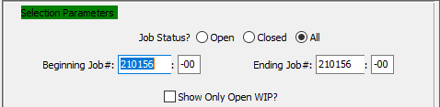

#### Job Status? (Choice)

To choose the preferred Job Status of Open vs. Closed (Or All), please make sure the desired option choice bubble is toggled.

#### Beginning Job # / Ending Job #

Enter the beginning and ending Job Number to run the report for.

#### Beginning Job #: 00 / Ending Job #: 00

Enter the beginning and ending Subsequent Job Number to run the report for.

#### Show only Open WIP? – Toggle Box

To show only open works in process, make sure that this toggle box is checked.

### Available and Selected Columns

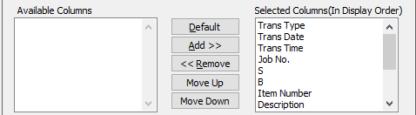

#### Available Columns

The user may choose which columns they wish to have on the report printout. As the user selects their choices, they will appear on the ‘*Selected Columns’* list.

#### Selected Columns (In Display Order)

The columns that the user has chosen from the ‘*Available Columns’* list. The order that these columns are displayed in here is the order in which they will print on the report.

#### Default

Click the ***“Default****”* button to sort the ‘*Selected Columns’* list by the default system parameters.

#### Add >>

Click on the selected item from the ‘*Available Columns’* list to highlight it, then click the ***“Add”*** button to add the selected column to the ‘*Selected Columns’* list.

#### << Remove

Click on the selected item from the ‘*Selected Columns’* list to highlight it, then click the ***“Remove”*** button to remove the selected column to the ‘*Selected Columns’* list.

#### Move Up

Within the ‘*Selected Columns’* list, the user may choose the order they wish the selected columns to print in. In order to change the order of the columns, the user can click on a selection to highlight it. By then clicking the ***“Move Up***” button, the user can change its position on the report.

#### Move Down

Within the ‘*Selected Columns’* list, the user may choose the order they wish the selected columns to print in. In order to change the order of the columns, the user can click on a selection to highlight it. By then clicking the ***“Move Down***” button, the user can change its position on the report.

### Output Destination

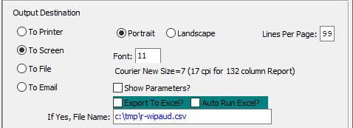

#### Destination Choice

To choose the destination where the document should be printed, please make sure that desired output destination choice bubble is toggled.

#### Layout Choice

To choose the preferred layout of Landscape vs. Portrait, please make sure the desired option choice bubbled is toggled.

#### Lines Per Page

Lines per page on the report when printing.

#### Font

Enter the font number to use with this report (Font 11 is default).

#### Show Parameters? – Toggle Box

To show parameters, make sure that the toggle box is ‘ticked’ with a checkmark.

#### Export to Excel? – Toggle Box

To export the printed file to an excel document, make sure that the Export to Excel toggle box is checked.

#### Auto Run Excel? – Toggle Box

To automatically open the new excel document, make sure that the Auto Run Excel toggle box is checked.

#### If Yes, File Name

If exporting the file to Excel, enter the desired file name.

## W.I.P. Daily Summary [JR2]

The work in process (WIP) daily summary is identical to the job audit trail but is a combination of all jobs for the day. This provides a complete summary of all the material and labor costs for the entire day for all jobs including material, machine hours, waste and finished goods receipts.

The print selection allows limited the report by a range of job numbers for a specific day. The report may be output to a computer screen, printer, fax, email or directly text file or to an excel format.

### Selection Parameters

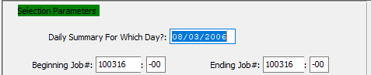

#### Daily Summary for Which Day?

Enter a date to print a daily summary for.

#### Beginning Job # / Ending Job #

Enter the beginning and ending Job Number to run the report for.

#### Beginning Job 3: 00 / Ending Job #: 00

Enter the beginning and ending Subsequent Job Number to run the report for.

### Available and Selected Columns

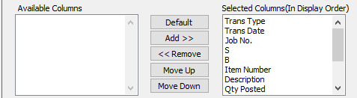

#### Available Columns

The user may choose which columns they wish to have on the report printout. As the user selects their choices, they will appear on the ‘*Selected Columns’* list.

#### Selected Columns (In Display Order)

The columns that the user has chosen from the ‘*Available Columns’* list. The order that these columns are displayed in here is the order in which they will print on the report.

#### Default

Click the ***“Default****”* button to sort the ‘*Selected Columns’* list by the default system parameters.

#### Add >>

Click on the selected item from the ‘*Available Columns’* list to highlight it, then click the ***“Add”*** button to add the selected column to the ‘*Selected Columns’* list.

#### << Remove

Click on the selected item from the ‘*Selected Columns’* list to highlight it, then click the ***“Remove”*** button to remove the selected column to the ‘*Selected Columns’* list.

#### Move Up

Within the ‘*Selected Columns’* list, the user may choose the order they wish the selected columns to print in. In order to change the order of the columns, the user can click on a selection to highlight it. By then clicking the ***“Move Up***” button, the user can change its position on the report.

#### Move Down

Within the ‘*Selected Columns’* list, the user may choose the order they wish the selected columns to print in. In order to change the order of the columns, the user can click on a selection to highlight it. By then clicking the ***“Move Down***” button, the user can change its position on the report.

### Output Destination

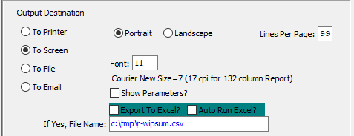

#### Destination Choice

To choose the destination where the document should be printed, please make sure that desired output destination choice bubble is toggled.

#### Layout Choice

To choose the preferred layout of Landscape vs. Portrait, please make sure the desired option choice bubbled is toggled.

#### Lines Per Page

Lines per page on the report when printing.

#### Font

Enter the font number to use with this report (Font 11 is default).

#### Show Parameters? – Toggle Box

To show parameters, make sure that the toggle box is ‘ticked’ with a checkmark.

#### Export to Excel? – Toggle Box

To export the printed file to an excel document, make sure that the Export to Excel toggle box is checked.

#### Auto Run Excel? – Toggle Box

To automatically open the new excel document, make sure that the Auto Run Excel toggle box is checked.

#### If Yes, File Name

If exporting the file to Excel, enter the desired file name.

## Job Summary [JR3]

### Report Overview

The job summary report shows actual quantity and costs of materials issued to the job as well as machine hours and direct labor posted to the job. The actual totals are compared to the standard material, direct labor, fixed overhead and variable overhead are recalculated based on actual quantity produced.

Standard materials will print the job file materials required based on the job quantity if the job has not produced any finished goods. Once the job is closed and finished goods are produced, the standard sheets are calculated using the total finished goods produced for the job. The total number of sheets for each form is calculated by the total of each item produced divided by the number up on the die for that item, which is found on the GOTO folder of the estimate.

### Selection Parameters

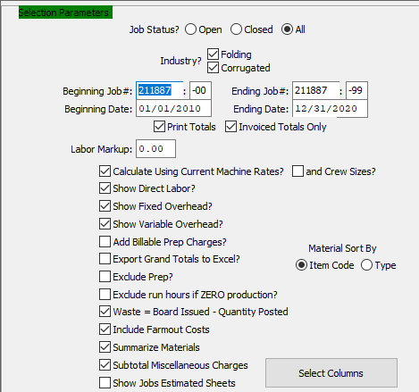

#### Job Status? (Choice)

To choose the preferred Job Status of Open vs. Closed (Or All), please make sure the desired option choice bubble is toggled.

#### Industry? Folding – Toggle Box

To include folding boxes in the report, make sure that the Folding toggle box is checked.

#### Industry? Corrugated – Toggle Box

To include corrugated boxes in the report, make sure that the Corrugated toggle box is checked.

#### Beginning Job # / Ending Job #

Enter the beginning and ending Job Number to run the report for.

#### Beginning Job #: 00 / Ending Job #: 00

Enter the beginning and ending Subsequent Job Number to run the report for.

#### Beginning Date / Ending Date

Enter the beginning and ending Date to run the report for.

#### Print Totals – Toggle Box

To print totals on the report, make sure that the Print Totals toggle box is checked.

#### Invoiced Totals Only – Toggle Box

To only print invoiced totals, make sure that the Invoiced Totals Only toggle box is checked.

#### Labor Markup

Enter the markup percentage for all labor here.

#### Calculate Using Current Machine Rates? – Toggle Box

To calculate totals using current machine rates, make sure that this toggle box is checked.

#### And Crew Sizes? – Toggle Box

To calculate totals using current crew sizes, make sure that the And Crew Sizes toggle box is checked.

#### Show Direct Labor? – Toggle Box

To show direct labor costs on the report, make sure that the Show Direct Labor toggle box is checked.

#### Show Fixed Overhead? – Toggle Box

To show fixed overhead costs on the report, make sure that the Show Fixed Overhead toggle box is checked.

#### Show Variable Overhead? – Toggle Box

To show variable overhead costs on the report, make sure that the Show Variable Overhead toggle box is checked.

#### Add Billable Prep Charges? – Toggle Box

To add billable prep charges on the report, make sure that the Add Billable Prep Charges toggle box is checked.

#### Export Grand Totals to Excel? – Toggle Box

To export all grand totals to an excel file, make sure that this toggle box is checked.

#### Exclude Prep? – Toggle Box

To exclude prep charges from the report, make sure that the Exclude Prep toggle box is checked.

#### Exclude Run Hours if Zero Production? – Toggle Box

To exclude run hours form the report if their production time is equal to zero, make sure that this toggle box is checked.

#### Waste = Board Issued – Quantity Posted – Toggle Box

To have the waste costs calculate themselves before printing to the report, make sure that this toggle box is checked.

#### Include Farmout Costs – Toggle Box

To include farmout costs from the report, make sure that the Include Farmout Costs toggle box is checked.

#### Summarize Materials – Toggle Box

To summarize materials on the report, make sure that the Summarize Materials toggle box is checked.

#### Subtotal Miscellaneous Charges – Toggle Box

To subtotal miscellaneous charges on the report, make sure that the Subtotal Miscellaneous Charges toggle box is checked.

#### Show Jobs Estimated Sheets – Toggle Box

To show estimated sheets on the report, make sure that the Show Jobs Estimated Sheets toggle box is checked.

#### Material Sort By (Choice)

To choose the preferred Sorting Method of Item Code vs. Item Type, please make sure the desired option choice bubble is toggled.

#### SELECT COLUMNS

Click the ***“Select Columns”*** button to bring up the popup window in which the user may select which columns they wish to print to the report, and in what order they will be arranged.

### Available and Selected Columns

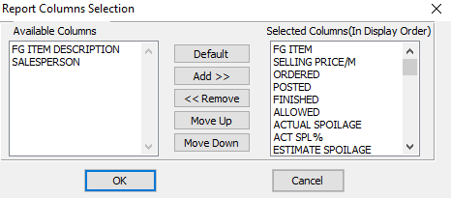

#### Available Columns

The user may choose which columns they wish to have on the report printout. As the user selects their choices, they will appear on the ‘*Selected Columns’* list.

#### Selected Columns (In Display Order)

The columns that the user has chosen from the ‘*Available Columns’* list. The order that these columns are displayed in here is the order in which they will print on the report.

#### Default

Click the ***“Default****”* button to sort the ‘*Selected Columns’* list by the default system parameters.

#### Add >>

Click on the selected item from the ‘*Available Columns’* list to highlight it, then click the ***“Add”*** button to add the selected column to the ‘*Selected Columns’* list.

#### << Remove

Click on the selected item from the ‘*Selected Columns’* list to highlight it, then click the ***“Remove”*** button to remove the selected column to the ‘*Selected Columns’* list.

#### Move Up

Within the ‘*Selected Columns’* list, the user may choose the order they wish the selected columns to print in. In order to change the order of the columns, the user can click on a selection to highlight it. By then clicking the ***“Move Up***” button, the user can change its position on the report.

#### Move Down

Within the ‘*Selected Columns’* list, the user may choose the order they wish the selected columns to print in. In order to change the order of the columns, the user can click on a selection to highlight it. By then clicking the ***“Move Down***” button, the user can change its position on the report.

### Output Destination

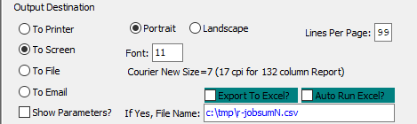

#### Destination Choice

To choose the destination where the document should be printed, please make sure that desired output destination choice bubble is toggled.

#### Layout Choice

To choose the preferred layout of Landscape vs. Portrait, please make sure the desired option choice bubbled is toggled.

#### Font

Enter the font number to use with this report (Font 11 is default).

#### Show Parameters? – Toggle Box

To show parameters, make sure that the toggle box is ‘ticked’ with a checkmark.

#### Export to Excel? – Toggle Box

To export the printed file to an excel document, make sure that the Export to Excel toggle box is checked.

#### Auto Run Excel? – Toggle Box

To automatically open the new excel document, make sure that the Auto Run Excel toggle box is checked.

#### If Yes, File Name

If exporting the file to Excel, enter the desired file name.

## Waste Analysis by Job [JR4]

The waste analysis by job report shows waste by sheet and blank for each machine. The report compares actual versus estimated standard waste for make ready and run for any specific date range. The report is useful to see what jobs are losing money, what operators or machines may need help or may need to be replaced.

Lastly, this report can be used as a tool to upgrade your machine standards for make ready and run waste standards in the machine file. The report may be output computer screen, printer, fax, email or directly text file or to an excel format.

The print selection allows limited the report by machine department, machine code, job number range for any date range with the quantity of waste shown in sheets or finished blank items.

### Selection Parameters

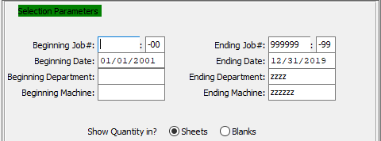

#### Beginning Job # / Ending Job #

Enter the beginning and ending Job Number to run the report for.

#### Beginning Job #: 00 / Ending Job #: 00

Enter the beginning and ending Subsequent Job Number to run the report for.

#### Beginning Date / Ending Date

Enter the beginning and ending Date to run the report for.

#### Beginning Department / Ending Department

Enter the beginning and ending Department to run the report for.

#### Beginning Machine / Ending Machine

Enter the beginning and ending Machine to run the report for.

#### Show Quantity In? (Choice)

To choose the preferred Quantity of Sheets vs. Blanks, please make sure the desired option choice bubble is toggled.

### Available and Selected Columns

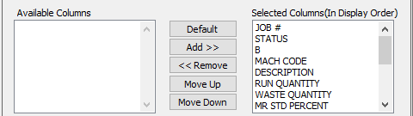

#### Available Columns

The user may choose which columns they wish to have on the report printout. As the user selects their choices, they will appear on the ‘*Selected Columns’* list.

#### Selected Columns (In Display Order)

The columns that the user has chosen from the ‘*Available Columns’* list. The order that these columns are displayed in here is the order in which they will print on the report.

#### Default

Click the ***“Default****”* button to sort the ‘*Selected Columns’* list by the default system parameters.

#### Add >>

Click on the selected item from the ‘*Available Columns’* list to highlight it, then click the ***“Add”*** button to add the selected column to the ‘*Selected Columns’* list.

#### << Remove

Click on the selected item from the ‘*Selected Columns’* list to highlight it, then click the ***“Remove”*** button to remove the selected column to the ‘*Selected Columns’* list.

#### Move Up

Within the ‘*Selected Columns’* list, the user may choose the order they wish the selected columns to print in. In order to change the order of the columns, the user can click on a selection to highlight it. By then clicking the ***“Move Up***” button, the user can change its position on the report.

#### Move Down

Within the ‘*Selected Columns’* list, the user may choose the order they wish the selected columns to print in. In order to change the order of the columns, the user can click on a selection to highlight it. By then clicking the ***“Move Down***” button, the user can change its position on the report.

### Output Destination

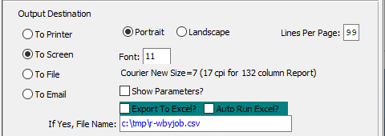

#### Destination Choice

To choose the destination where the document should be printed, please make sure that desired output destination choice bubble is toggled.

#### Layout Choice

To choose the preferred layout of Landscape vs. Portrait, please make sure the desired option choice bubbled is toggled.

#### Show Parameters? – Toggle Box

To show parameters, make sure that the toggle box is ‘ticked’ with a checkmark.

#### Export to Excel? – Toggle Box

To export the printed file to an excel document, make sure that the Export to Excel toggle box is checked.

#### Auto Run Excel? – Toggle Box

To automatically open the new excel document, make sure that the Auto Run Excel toggle box is checked.

#### If Yes, File Name

If exporting the file to Excel, enter the desired file name.

## Closed Job Analysis [JR5]

### Selection Parameters

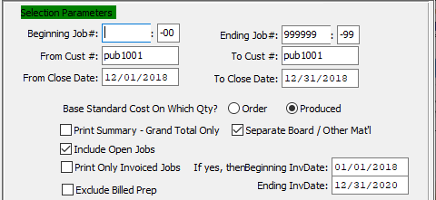

#### Beginning Job # / Ending Job #

Enter the beginning and ending Job Number to run the report for.

#### Beginning Job #: 00 / Ending Job #: 00

Enter the beginning and ending Subsequent Job Number to run the report for.

#### From Customer # / To Customer #

Enter the beginning and ending Customer Number to run the report for.

#### From Close Date / To Close Date

Enter the beginning and ending Close Date to run the report for.

#### Base Standard on Which Qty? (Choice)

To choose the preferred Quantity of Order vs. Produced, please make sure the desired option choice bubble is toggled.

#### Print Summary – Grand Total Only – Toggle Box

To print only a summary and the grand total of the closed jobs, make sure that this toggle box is checked.

#### Separate Board / Other Material – Toggle Box

To separate materials on the report, make sure that this toggle box is checked.

#### Include Open Jobs – Toggle Box

To include any open jobs within the parameters as well, make sure that the Include Open Jobs toggle box is checked.

#### Print Only Invoiced Jobs – Toggle Box

To print only invoiced jobs on the report, make sure that the Print Only Invoiced Jobs toggle box is checked.

#### If Yes, the Beginning Invoice Date / Ending Invoice Date

If the user has chosen to print only invoiced jobs on the Closed Job Analysis report, they must enter the beginning and ending Invoice Date to run the report for.

#### Exclude Billed Prep – Toggle Box

To exclude billed prep costs from the report, make sure that the Exclude Billed Prep toggle box is checked.

### Available and Selected Columns

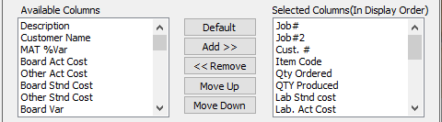

#### Available Columns

The user may choose which columns they wish to have on the report printout. As the user selects their choices, they will appear on the ‘*Selected Columns’* list.

#### Selected Columns (In Display Order)

The columns that the user has chosen from the ‘*Available Columns’* list. The order that these columns are displayed in here is the order in which they will print on the report.

#### Default

Click the ***“Default****”* button to sort the ‘*Selected Columns’* list by the default system parameters.

#### Add >>

Click on the selected item from the ‘*Available Columns’* list to highlight it, then click the ***“Add”*** button to add the selected column to the ‘*Selected Columns’* list.

#### << Remove

Click on the selected item from the ‘*Selected Columns’* list to highlight it, then click the ***“Remove”*** button to remove the selected column to the ‘*Selected Columns’* list.

#### Move Up

Within the ‘*Selected Columns’* list, the user may choose the order they wish the selected columns to print in. In order to change the order of the columns, the user can click on a selection to highlight it. By then clicking the ***“Move Up***” button, the user can change its position on the report.

#### Move Down

Within the ‘*Selected Columns’* list, the user may choose the order they wish the selected columns to print in. In order to change the order of the columns, the user can click on a selection to highlight it. By then clicking the ***“Move Down***” button, the user can change its position on the report.

### Output Destination

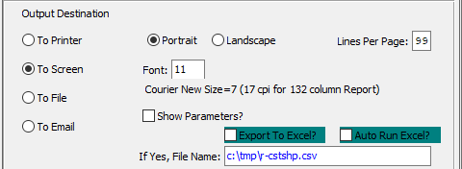

#### Destination Choice

To choose the destination where the document should be printed, please make sure that desired output destination choice bubble is toggled.

#### Layout Choice

To choose the preferred layout of Landscape vs. Portrait, please make sure the desired option choice bubbled is toggled.

#### Lines Per Page

Lines per page on the report when printing.

#### Font

Enter the font number to use with this report (Font 11 is default).

#### Show Parameters? – Toggle Box

To show parameters, make sure that the toggle box is ‘ticked’ with a checkmark.

#### Export to Excel? – Toggle Box

To export the printed file to an excel document, make sure that the Export to Excel toggle box is checked.

#### Auto Run Excel? – Toggle Box

To automatically open the new excel document, make sure that the Auto Run Excel toggle box is checked.

#### If Yes, File Name

If exporting the file to Excel, enter the desired file name.

## Machine Cost by Job [JR7]

The machine cost by job summary report is a very summarized analysis of job costs. This report provides a snapshot of estimated versus actual cost by machine for make ready, run and board costs.

The print selection allows limited the report by job status, machine range and range of job numbers for any date range. The report may be output to any computer screen, printer, fax, email or directly text file or to an excel format.

### Selection Parameters

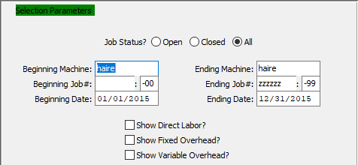

#### Job Status? (Choice)

To choose the preferred Job Status of Open vs. Closed (Or All), please make sure the desired option choice bubble is toggled.

#### Beginning Machine / Ending Machine

Enter the beginning and ending Machine to run the report for.

#### Beginning Job # / Ending Job #

Enter the beginning and ending Job Number to run the report for.

#### Beginning Job #: 00 / Ending Job #: 00

Enter the beginning and ending Subsequent Job Number to run the report for.

#### Beginning Date / Ending Date

Enter the beginning and ending Date to run the report for.

#### Show Direct Labor? – Toggle Box

To show the direct labor cost, make sure that the Show Direct Labor toggle box is checked.

#### Show Fixed Overhead – Toggle Box

To show the fixed overhead cost, make sure that the Show Fixed Overhead toggle box is checked.

#### Show Variable Overhead? – Toggle Box

To show the variable overhead cost, make sure that the Show Variable Overhead toggle box is checked.

### Available and Selected Columns

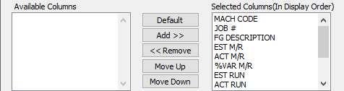

#### Available Columns

The user may choose which columns they wish to have on the report printout. As the user selects their choices, they will appear on the ‘*Selected Columns’* list.

#### Selected Columns (In Display Order)

The columns that the user has chosen from the ‘*Available Columns’* list. The order that these columns are displayed in here is the order in which they will print on the report.

#### Default

Click the ***“Default****”* button to sort the ‘*Selected Columns’* list by the default system parameters.

#### Add >>

Click on the selected item from the ‘*Available Columns’* list to highlight it, then click the ***“Add”*** button to add the selected column to the ‘*Selected Columns’* list.

#### << Remove

Click on the selected item from the ‘*Selected Columns’* list to highlight it, then click the ***“Remove”*** button to remove the selected column to the ‘*Selected Columns’* list.

#### Move Up

Within the ‘*Selected Columns’* list, the user may choose the order they wish the selected columns to print in. In order to change the order of the columns, the user can click on a selection to highlight it. By then clicking the ***“Move Up***” button, the user can change its position on the report.

#### Move Down

Within the ‘*Selected Columns’* list, the user may choose the order they wish the selected columns to print in. In order to change the order of the columns, the user can click on a selection to highlight it. By then clicking the ***“Move Down***” button, the user can change its position on the report.

### Output Destination

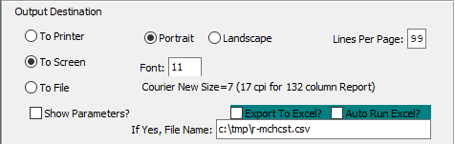

#### Destination Choice

To choose the destination where the document should be printed, please make sure that desired output destination choice bubble is toggled.

#### Layout Choice

To choose the preferred layout of Landscape vs. Portrait, please make sure the desired option choice bubbled is toggled.

#### Lines Per Page

Lines per page on the report when printing.

#### Font

Enter the font number to use with this report (Font 11 is default).

#### Show Parameters? – Toggle Box

To show parameters, make sure that the toggle box is ‘ticked’ with a checkmark.

#### Export to Excel? – Toggle Box

To export the printed file to an excel document, make sure that the Export to Excel toggle box is checked.

#### Auto Run Excel? – Toggle Box

To automatically open the new excel document, make sure that the Auto Run Excel toggle box is checked.

#### If Yes, File Name

If exporting the file to Excel, enter the desired file name.

## Board Reconciliation [JR8]

The board reconciliation is summary of waste for an entire job showing total board issued to the job compared to the finished goods received and invoiced. It is also a very useful tool to make sure all the jobs have been fully invoiced.

The print selection allows limited the report by job status, item code, product category, job number range and any date range.

### Selection Parameters

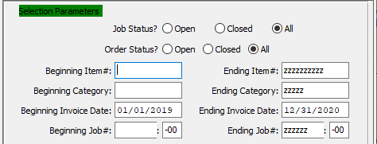

#### Job Status? (Choice)

To choose the preferred Job Status of Open vs. Closed (Or All), please make sure the desired option choice bubble is toggled.

#### Order Status? (Choice)

To choose the preferred Order Status of Open vs. Closed (Or All), please make sure the desired option choice bubble is toggled.

#### Beginning Item # / Ending Item #

Enter the beginning and ending Item Number to run the report for.

#### Beginning Category / Ending Category

Enter the beginning and ending Category to run the report for.

#### Beginning Invoice Date / Ending Invoice Date

Enter the beginning and ending Invoice Date to run the report for.

#### Beginning Job # / Ending Job #

Enter the beginning and ending Job Number to run the report for.

#### Beginning Job #: 00 / Ending Job #: 00

Enter the beginning and ending Subsequent Job Number to run the report for.

### Available and Selected Columns

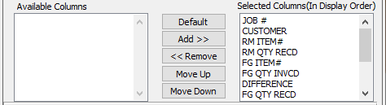

#### Available Columns

The user may choose which columns they wish to have on the report printout. As the user selects their choices, they will appear on the ‘*Selected Columns’* list.

#### Selected Columns (In Display Order)

The columns that the user has chosen from the ‘*Available Columns’* list. The order that these columns are displayed in here is the order in which they will print on the report.

#### Default

Click the ***“Default****”* button to sort the ‘*Selected Columns’* list by the default system parameters.

#### Add >>

Click on the selected item from the ‘*Available Columns’* list to highlight it, then click the ***“Add”*** button to add the selected column to the ‘*Selected Columns’* list.

#### << Remove

Click on the selected item from the ‘*Selected Columns’* list to highlight it, then click the ***“Remove”*** button to remove the selected column to the ‘*Selected Columns’* list.

#### Move Up

Within the ‘*Selected Columns’* list, the user may choose the order they wish the selected columns to print in. In order to change the order of the columns, the user can click on a selection to highlight it. By then clicking the ***“Move Up***” button, the user can change its position on the report.

#### Move Down

Within the ‘*Selected Columns’* list, the user may choose the order they wish the selected columns to print in. In order to change the order of the columns, the user can click on a selection to highlight it. By then clicking the ***“Move Down***” button, the user can change its position on the report.

### Output Destination

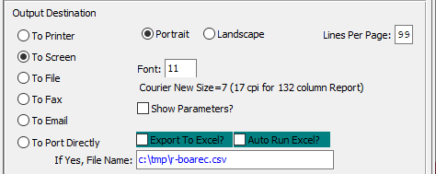

#### Destination Choice

To choose the destination where the document should be printed, please make sure that desired output destination choice bubble is toggled.

#### Layout Choice

To choose the preferred layout of Landscape vs. Portrait, please make sure the desired option choice bubbled is toggled.

#### Lines Per Page

Lines per page on the report when printing.

#### Font

Enter the font number to use with this report (Font 11 is default).

#### Show Parameters? – Toggle Box

To show parameters, make sure that the toggle box is ‘ticked’ with a checkmark.

#### Export to Excel? – Toggle Box

To export the printed file to an excel document, make sure that the Export to Excel toggle box is checked.

#### Auto Run Excel? – Toggle Box

To automatically open the new excel document, make sure that the Auto Run Excel toggle box is checked.

#### If Yes, File Name

If exporting the file to Excel, enter the desired file name.

## Job/Vendor Analysis [JR9]

### Selection Parameters

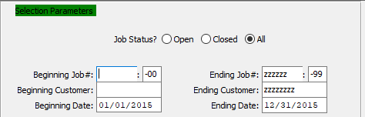

#### Job Status? (Choice)

To choose the preferred Job Status of Open vs. Closed (Or All), please make sure the desired option choice bubble is toggled.

#### Beginning Job # / Ending Job #

Enter the beginning and ending Job Number to run the report for.

#### Beginning Job #: 00 / Ending Job #: 00

Enter the beginning and ending Subsequent Job Number to run the report for.

#### Beginning Customer / Ending Customer

Enter the beginning and ending Customer to run the report for.

#### Beginning Date / Ending Date

Enter the beginning and ending Date to run the report for.

### Available and Selected Columns

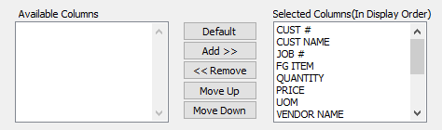

#### Available Columns

The user may choose which columns they wish to have on the report printout. As the user selects their choices, they will appear on the ‘*Selected Columns’* list.

#### Selected Columns (In Display Order)

The columns that the user has chosen from the ‘*Available Columns’* list. The order that these columns are displayed in here is the order in which they will print on the report.

#### Default

Click the ***“Default****”* button to sort the ‘*Selected Columns’* list by the default system parameters.

#### Add >>

Click on the selected item from the ‘*Available Columns’* list to highlight it, then click the ***“Add”*** button to add the selected column to the ‘*Selected Columns’* list.

#### << Remove

Click on the selected item from the ‘*Selected Columns’* list to highlight it, then click the ***“Remove”*** button to remove the selected column to the ‘*Selected Columns’* list.

#### Move Up

Within the ‘*Selected Columns’* list, the user may choose the order they wish the selected columns to print in. In order to change the order of the columns, the user can click on a selection to highlight it. By then clicking the ***“Move Up***” button, the user can change its position on the report.

#### Move Down

Within the ‘*Selected Columns’* list, the user may choose the order they wish the selected columns to print in. In order to change the order of the columns, the user can click on a selection to highlight it. By then clicking the ***“Move Down***” button, the user can change its position on the report.

### Output Destination

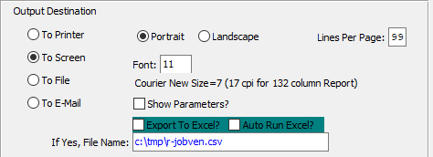

#### Destination Choice

To choose the destination where the document should be printed, please make sure that desired output destination choice bubble is toggled.

#### Layout Choice

To choose the preferred layout of Landscape vs. Portrait, please make sure the desired option choice bubbled is toggled.

#### Font

Enter the font number to use with this report (Font 11 is default).

#### Show Parameters? – Toggle Box

To show parameters, make sure that the toggle box is ‘ticked’ with a checkmark.

#### Export to Excel? – Toggle Box

To export the printed file to an excel document, make sure that the Export to Excel toggle box is checked.

#### Auto Run Excel? – Toggle Box

To automatically open the new excel document, make sure that the Auto Run Excel toggle box is checked.

#### If Yes, File Name

If exporting the file to Excel, enter the desired file name.

## Job Backlog by Machine [JR)]

The job backlog shows the remaining hours and remaining machines for each job for each date.

The print selection allows limited the report by a range of machines or job numbers as of a specific date by either the start date or the due state. The report may be output to a computer screen, printer, fax, email or directly text file or to an excel format.

### Selection Parameters

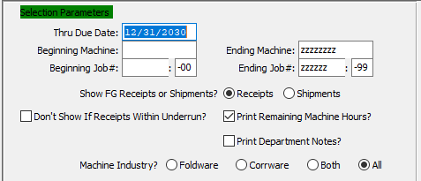

#### Through Due Date

In this field, the user may enter a due date to end the report. All jobs within the subsequent parameters up to this date will print to the report.

#### Beginning Machine / Ending Machine

Enter the beginning and ending Machine to run the report for.

#### Beginning Job # / Ending Job #

Enter the beginning and ending Job Number to run the report for.

#### Beginning Job #: 00 / Ending Job #: 00

Enter the beginning and ending Subsequent Job Number to run the report for.

#### Show FG Receipts or Shipments? (Choice)

To choose the preferred Finished Good of Receipts vs. Shipments, please make sure the desired option choice bubble is toggled.

#### Don’t Show if Receipts Within Underrun? – Toggle Box

To exclude jobs where the receipt is in underrun from the backlog report, make sure that this toggle box is checked.

#### Print Remaining Machine Hours? – Toggle Box

To print the remaining machine hours needed on the report, make sure that this toggle box is checked.

#### Print Department Notes? – Toggle Box

To print department notes on the report, make sure that the Print Department Notes toggle box is checked.

#### Machine Industry? (Choice)

To choose the preferred Machine Industry, please make sure the desired option choice bubble is toggled.

### Available and Selected Columns

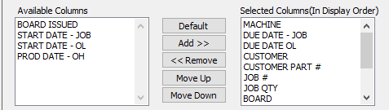

#### Available Columns

The user may choose which columns they wish to have on the report printout. As the user selects their choices, they will appear on the ‘*Selected Columns’* list.

#### Selected Columns (In Display Order)

The columns that the user has chosen from the ‘*Available Columns’* list. The order that these columns are displayed in here is the order in which they will print on the report.

#### Default

Click the ***“Default****”* button to sort the ‘*Selected Columns’* list by the default system parameters.

#### Add >>

Click on the selected item from the ‘*Available Columns’* list to highlight it, then click the ***“Add”*** button to add the selected column to the ‘*Selected Columns’* list.

#### << Remove

Click on the selected item from the ‘*Selected Columns’* list to highlight it, then click the ***“Remove”*** button to remove the selected column to the ‘*Selected Columns’* list.

#### Move Up

Within the ‘*Selected Columns’* list, the user may choose the order they wish the selected columns to print in. In order to change the order of the columns, the user can click on a selection to highlight it. By then clicking the ***“Move Up***” button, the user can change its position on the report.

#### Move Down

Within the ‘*Selected Columns’* list, the user may choose the order they wish the selected columns to print in. In order to change the order of the columns, the user can click on a selection to highlight it. By then clicking the ***“Move Down***” button, the user can change its position on the report.

### Output Destination

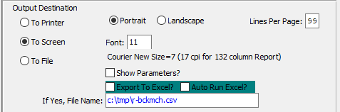

#### Destination Choice

To choose the destination where the document should be printed, please make sure that desired output destination choice bubble is toggled.

#### Layout Choice

To choose the preferred layout of Landscape vs. Portrait, please make sure the desired option choice bubbled is toggled.

#### Lines Per Page

Lines per page on the report when printing.

#### Font

Enter the font number to use with this report (Font 11 is default).

#### Show Parameters? – Toggle Box

To show parameters, make sure that the toggle box is ‘ticked’ with a checkmark.

#### Export to Excel? – Toggle Box

To export the printed file to an excel document, make sure that the Export to Excel toggle box is checked.

#### Auto Run Excel? – Toggle Box

To automatically open the new excel document, make sure that the Auto Run Excel toggle box is checked.

#### If Yes, File Name

If exporting the file to Excel, enter the desired file name.

## Job Backlog by MSF/Kicks [JR!]

The machine backlog report shows machine backlog represented by kicks, which is the same as impressions or sheets. This is printed up to a specific date, while printing the details of each job for the day including hours required and hours remaining.

The visual scheduling software provides far greater visual and reporting options, but this report can be used when the scheduling module is not purchased.

The print selection allows limited the report by machine department, machine code up to a specific start date or due date. The report also has an option to print either the machine description or customer name. The report may be output computer screen, printer, fax, email or directly text file or to an excel format.

### Selection Parameters

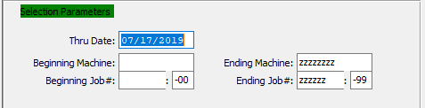

#### Through Date

In this field, the user may enter a date to end the report. All jobs within the subsequent parameters up to this date will print to the report.

#### Beginning Machine / Ending Machine

Enter the beginning and ending Machine to run the report for.

#### Beginning Job # / Ending Job #

Enter the beginning and ending Job Number to run the report for.

#### Beginning Job #: 00 / Ending Job #: 00

Enter the beginning and ending Subsequent Job Number to run the report for.

### Available and Selected Columns

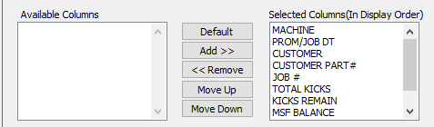

#### Available Columns

The user may choose which columns they wish to have on the report printout. As the user selects their choices, they will appear on the ‘*Selected Columns’* list.

#### Selected Columns (In Display Order)

The columns that the user has chosen from the ‘*Available Columns’* list. The order that these columns are displayed in here is the order in which they will print on the report.

#### Default

Click the ***“Default****”* button to sort the ‘*Selected Columns’* list by the default system parameters.

#### Add >>

Click on the selected item from the ‘*Available Columns’* list to highlight it, then click the ***“Add”*** button to add the selected column to the ‘*Selected Columns’* list.

#### << Remove

Click on the selected item from the ‘*Selected Columns’* list to highlight it, then click the ***“Remove”*** button to remove the selected column to the ‘*Selected Columns’* list.

#### Move Up

Within the ‘*Selected Columns’* list, the user may choose the order they wish the selected columns to print in. In order to change the order of the columns, the user can click on a selection to highlight it. By then clicking the ***“Move Up***” button, the user can change its position on the report.

#### Move Down

Within the ‘*Selected Columns’* list, the user may choose the order they wish the selected columns to print in. In order to change the order of the columns, the user can click on a selection to highlight it. By then clicking the ***“Move Down***” button, the user can change its position on the report.

### Output Destination

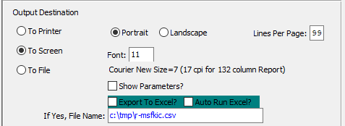

#### Destination Choice

To choose the destination where the document should be printed, please make sure that desired output destination choice bubble is toggled.

#### Layout Choice

To choose the preferred layout of Landscape vs. Portrait, please make sure the desired option choice bubbled is toggled.

#### Lines Per Page

Lines per page on the report when printing.

#### Font

Enter the font number to use with this report (Font 11 is default).

#### Show Parameters? – Toggle Box

To show parameters, make sure that the toggle box is ‘ticked’ with a checkmark.

#### Export to Excel? – Toggle Box

To export the printed file to an excel document, make sure that the Export to Excel toggle box is checked.

#### Auto Run Excel? – Toggle Box

To automatically open the new excel document, make sure that the Auto Run Excel toggle box is checked.

#### If Yes, File Name

If exporting the file to Excel, enter the desired file name.

## WIP by Product Category [JR@]

The Work in Process report shows the value of work in process by calculating the actual labor and actual material costs that have been posted to the job, then subtracting the material and labor costs that have been received into Finished Goods. When adding a job, the cost per thousand is calculated from the estimate machine and material standards.

### Selection Parameters

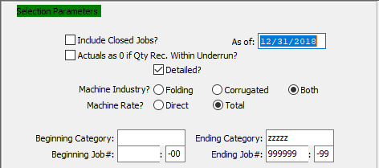

#### Include Closed Jobs? – Toggle Box

To included closed job in the report, make sure that the Include Closed Jobs toggle box is checked.

#### As Of

If the user has elected to include closed jobs in the report, they may enter a specific date in this field. The report will then include all jobs that have been closed as of that specific date.

#### Actuals s 0 if Quantity Rec. Within Underrun? – Toggle Box

To mark actuals as zero, make sure that this toggle box is checked.

#### Detailed? – Toggle Box

To print a detailed report, make sure that the Detailed toggle box is checked.

#### Machine Industry? – (Choice)

To choose the preferred Machine Industry of Folding vs. Corrugated (Or Both), please make sure the desired option choice bubble is toggled.

#### Machine Rate? (Choice)

To choose the preferred Machine Rate of Direct vs. Total, please make sure the desired option choice bubble is toggled.

#### Beginning Category / Ending Category

Enter the beginning and ending Category to run the report for.

#### Beginning Job # / Ending Job #

Enter the beginning and ending Job Number to run the report for.

#### Beginning Job #: 00 / Ending Job #: 00

Enter the beginning and ending Subsequent Job Number to run the report for.

### Available and Selected Columns

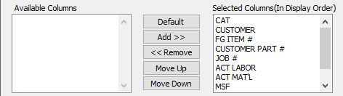

#### Available Columns

The user may choose which columns they wish to have on the report printout. As the user selects their choices, they will appear on the ‘*Selected Columns’* list.

#### Selected Columns (In Display Order)

The columns that the user has chosen from the ‘*Available Columns’* list. The order that these columns are displayed in here is the order in which they will print on the report.

#### Default

Click the ***“Default****”* button to sort the ‘*Selected Columns’* list by the default system parameters.

#### Add >>

Click on the selected item from the ‘*Available Columns’* list to highlight it, then click the ***“Add”*** button to add the selected column to the ‘*Selected Columns’* list.

#### << Remove

Click on the selected item from the ‘*Selected Columns’* list to highlight it, then click the ***“Remove”*** button to remove the selected column to the ‘*Selected Columns’* list.

#### Move Up

Within the ‘*Selected Columns’* list, the user may choose the order they wish the selected columns to print in. In order to change the order of the columns, the user can click on a selection to highlight it. By then clicking the ***“Move Up***” button, the user can change its position on the report.

#### Move Down

Within the ‘*Selected Columns’* list, the user may choose the order they wish the selected columns to print in. In order to change the order of the columns, the user can click on a selection to highlight it. By then clicking the ***“Move Down***” button, the user can change its position on the report.

### Output Destination

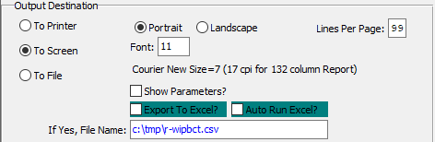

#### Destination Choice

To choose the destination where the document should be printed, please make sure that desired output destination choice bubble is toggled.

#### Layout Choice

To choose the preferred layout of Landscape vs. Portrait, please make sure the desired option choice bubbled is toggled.

#### Lines Per Page

Lines per page on the report when printing.

#### Font

Enter the font number to use with this report (Font 11 is default).

#### Show Parameters? – Toggle Box

To show parameters, make sure that the toggle box is ‘ticked’ with a checkmark.

#### Export to Excel? – Toggle Box

To export the printed file to an excel document, make sure that the Export to Excel toggle box is checked.

#### Auto Run Excel? – Toggle Box

To automatically open the new excel document, make sure that the Auto Run Excel toggle box is checked.

#### If Yes, File Name

If exporting the file to Excel, enter the desired file name.

## MSF by Job [JR#]

The job backlog shows the remaining hours and remaining machines for each job for each date.

The print selection allows limited the report by a range of machines or job numbers as of a specific date by either the start date or the due state. The report may be output to a computer screen, printer, fax, email or directly text file or to an excel format.

### Selection Parameters

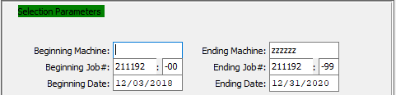

#### Beginning Machine / Ending Machine

Enter the beginning and ending Machine to run the report for.

#### Beginning Job # / Ending Job #

Enter the beginning and ending Job Number to run the report for.

#### Beginning Job #: 00 / Ending Job #: 00

Enter the beginning and ending Subsequent Job Number to run the report for.

#### Beginning Date / Ending Date

Enter the beginning and ending Date to run the report for.

### Available and Selected Columns

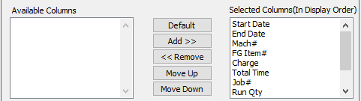

#### Available Columns

The user may choose which columns they wish to have on the report printout. As the user selects their choices, they will appear on the ‘*Selected Columns’* list.

#### Selected Columns (In Display Order)

The columns that the user has chosen from the ‘*Available Columns’* list. The order that these columns are displayed in here is the order in which they will print on the report.

#### Default

Click the ***“Default****”* button to sort the ‘*Selected Columns’* list by the default system parameters.

#### Add >>

Click on the selected item from the ‘*Available Columns’* list to highlight it, then click the ***“Add”*** button to add the selected column to the ‘*Selected Columns’* list.

#### << Remove

Click on the selected item from the ‘*Selected Columns’* list to highlight it, then click the ***“Remove”*** button to remove the selected column to the ‘*Selected Columns’* list.

#### Move Up

Within the ‘*Selected Columns’* list, the user may choose the order they wish the selected columns to print in. In order to change the order of the columns, the user can click on a selection to highlight it. By then clicking the ***“Move Up***” button, the user can change its position on the report.

#### Move Down

Within the ‘*Selected Columns’* list, the user may choose the order they wish the selected columns to print in. In order to change the order of the columns, the user can click on a selection to highlight it. By then clicking the ***“Move Down***” button, the user can change its position on the report.

### Output Destination

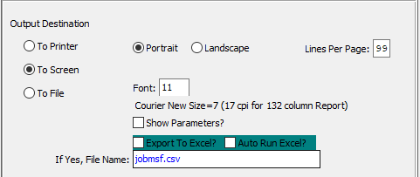

#### Destination Choice

To choose the destination where the document should be printed, please make sure that desired output destination choice bubble is toggled.

#### Layout Choice

To choose the preferred layout of Landscape vs. Portrait, please make sure the desired option choice bubbled is toggled.

#### Lines Per Page

Lines per page on the report when printing.

#### Font

Enter the font number to use with this report (Font 11 is default).

#### Show Parameters? – Toggle Box

To show parameters, make sure that the toggle box is ‘ticked’ with a checkmark.

#### Export to Excel? – Toggle Box

To export the printed file to an excel document, make sure that the Export to Excel toggle box is checked.

#### Auto Run Excel? – Toggle Box

To automatically open the new excel document, make sure that the Auto Run Excel toggle box is checked.

## Job/Est/PO Audit [JR$]

### Selection Parameters

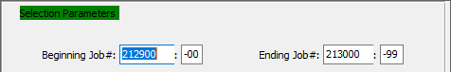

#### Beginning Job # / Ending Job #

Enter the beginning and ending Job Number to run the audit for.

#### Beginning Job #: 00 / Ending Job #: 00

Enter the beginning and ending Subsequent Job Number to run the audit for.

### Available and Selected Columns

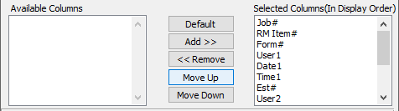

#### Available Columns

The user may choose which columns they wish to have on the report printout. As the user selects their choices, they will appear on the ‘*Selected Columns’* list.

#### Selected Columns (In Display Order)

The columns that the user has chosen from the ‘*Available Columns’* list. The order that these columns are displayed in here is the order in which they will print on the report.

#### Default

Click the ***“Default****”* button to sort the ‘*Selected Columns’* list by the default system parameters.

#### Add >>

Click on the selected item from the ‘*Available Columns’* list to highlight it, then click the ***“Add”*** button to add the selected column to the ‘*Selected Columns’* list.

#### << Remove

Click on the selected item from the ‘*Selected Columns’* list to highlight it, then click the ***“Remove”*** button to remove the selected column to the ‘*Selected Columns’* list.

#### Move Up

Within the ‘*Selected Columns’* list, the user may choose the order they wish the selected columns to print in. In order to change the order of the columns, the user can click on a selection to highlight it. By then clicking the ***“Move Up***” button, the user can change its position on the report.

#### Move Down

Within the ‘*Selected Columns’* list, the user may choose the order they wish the selected columns to print in. In order to change the order of the columns, the user can click on a selection to highlight it. By then clicking the ***“Move Down***” button, the user can change its position on the report.

### Output Destination

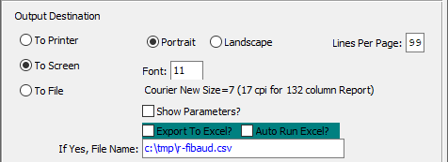

#### Destination Choice

To choose the destination where the document should be printed, please make sure that desired output destination choice bubble is toggled.

#### Layout Choice

To choose the preferred layout of Landscape vs. Portrait, please make sure the desired option choice bubbled is toggled.

#### Lines Per Page

Lines per page on the report when printing.

#### Font

Enter the font number to use with this report (Font 11 is default).

#### Show Parameters? – Toggle Box

To show parameters, make sure that the toggle box is ‘ticked’ with a checkmark.

#### Export to Excel? – Toggle Box

To export the printed file to an excel document, make sure that the Export to Excel toggle box is checked.

#### Auto Run Excel? – Toggle Box

To automatically open the new excel document, make sure that the Auto Run Excel toggle box is checked.

#### If Yes, File Name

If exporting the file to Excel, enter the desired file name.

# **Lists More Reports [JL]**

## Jobs Due Tracking [JL1]

### Selection Parameters

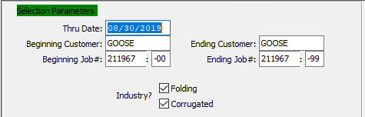

#### Through Date

In this field, the user may enter a date to end the report. All jobs within the subsequent parameters up to this date will print to the report.

#### Beginning Customer / Ending Customer

Enter the beginning and ending Customer to run the report for.

#### Beginning Job # / Ending Job #

Enter the beginning and ending Job Number to run the report for.

#### Beginning Job #: 00 / Ending Job #: 00

Enter the beginning and ending Subsequent Job Number to run the report for.

#### Industry? Folding – Toggle Box

To include Folding boxes in the tracking report, make sure that the Folding toggle box is checked.

#### Industry? Corrugated – Toggle Box

To include Corrugated boxes in the tracking report, make sure that the Corrugated toggle box is checked.

### Available and Selected Columns

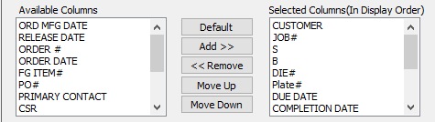

#### Available Columns

The user may choose which columns they wish to have on the report printout. As the user selects their choices, they will appear on the ‘*Selected Columns’* list.

#### Selected Columns (In Display Order)

The columns that the user has chosen from the ‘*Available Columns’* list. The order that these columns are displayed in here is the order in which they will print on the report.

#### Default

Click the ***“Default****”* button to sort the ‘*Selected Columns’* list by the default system parameters.

#### Add >>

Click on the selected item from the ‘*Available Columns’* list to highlight it, then click the ***“Add”*** button to add the selected column to the ‘*Selected Columns’* list.

#### << Remove

Click on the selected item from the ‘*Selected Columns’* list to highlight it, then click the ***“Remove”*** button to remove the selected column to the ‘*Selected Columns’* list.

#### Move Up

Within the ‘*Selected Columns’* list, the user may choose the order they wish the selected columns to print in. In order to change the order of the columns, the user can click on a selection to highlight it. By then clicking the ***“Move Up***” button, the user can change its position on the report.

#### Move Down

Within the ‘*Selected Columns’* list, the user may choose the order they wish the selected columns to print in. In order to change the order of the columns, the user can click on a selection to highlight it. By then clicking the ***“Move Down***” button, the user can change its position on the report.

### Output Destination

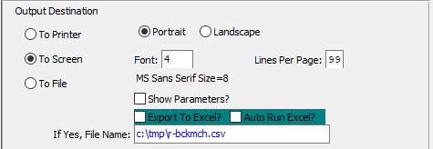

#### Destination Choice

To choose the destination where the document should be printed, please make sure that desired output destination choice bubble is toggled.

#### Layout Choice

To choose the preferred layout of Landscape vs. Portrait, please make sure the desired option choice bubbled is toggled.

#### Lines Per Page

Lines per page on the report when printing.

#### Font

Enter the font number to use with this report (Font 11 is default).

#### Show Parameters? – Toggle Box

To show parameters, make sure that the toggle box is ‘ticked’ with a checkmark.

#### Export to Excel? – Toggle Box

To export the printed file to an excel document, make sure that the Export to Excel toggle box is checked.

#### Auto Run Excel? – Toggle Box

To automatically open the new excel document, make sure that the Auto Run Excel toggle box is checked.

#### If Yes, File Name

If exporting the file to Excel, enter the desired file name.

## Open Jobs Backlog Report [JL2]

### Selection Parameters

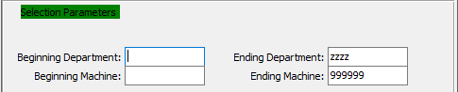

#### Beginning Department / Ending Department

Enter the beginning and ending Department to run the report for.

#### Beginning Machine / Ending Machine

Enter the beginning and ending Machine to run the report for.

### Available and Selected Columns

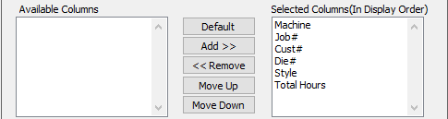

#### Available Columns

The user may choose which columns they wish to have on the report printout. As the user selects their choices, they will appear on the ‘*Selected Columns’* list.

#### Selected Columns (In Display Order)

The columns that the user has chosen from the ‘*Available Columns’* list. The order that these columns are displayed in here is the order in which they will print on the report.

#### Default

Click the ***“Default****”* button to sort the ‘*Selected Columns’* list by the default system parameters.

#### Add >>

Click on the selected item from the ‘*Available Columns’* list to highlight it, then click the ***“Add”*** button to add the selected column to the ‘*Selected Columns’* list.

#### << Remove

Click on the selected item from the ‘*Selected Columns’* list to highlight it, then click the ***“Remove”*** button to remove the selected column to the ‘*Selected Columns’* list.

#### Move Up

Within the ‘*Selected Columns’* list, the user may choose the order they wish the selected columns to print in. In order to change the order of the columns, the user can click on a selection to highlight it. By then clicking the ***“Move Up***” button, the user can change its position on the report.

#### Move Down

Within the ‘*Selected Columns’* list, the user may choose the order they wish the selected columns to print in. In order to change the order of the columns, the user can click on a selection to highlight it. By then clicking the ***“Move Down***” button, the user can change its position on the report.

### Output Destination

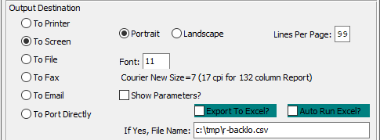

#### Destination Choice

To choose the destination where the document should be printed, please make sure that desired output destination choice bubble is toggled.

#### Layout Choice

To choose the preferred layout of Landscape vs. Portrait, please make sure the desired option choice bubbled is toggled.

#### Lines Per Page

Lines per page on the report when printing.

#### Font

Enter the font number to use with this report (Font 11 is default).

#### Show Parameters? – Toggle Box

To show parameters, make sure that the toggle box is ‘ticked’ with a checkmark.

#### Export to Excel? – Toggle Box

To export the printed file to an excel document, make sure that the Export to Excel toggle box is checked.

#### Auto Run Excel? – Toggle Box

To automatically open the new excel document, make sure that the Auto Run Excel toggle box is checked.

#### If Yes, File Name

If exporting the file to Excel, enter the desired file name.

## Total Weight and Sales by 1st Machine [JL3]

### Selection Parameters

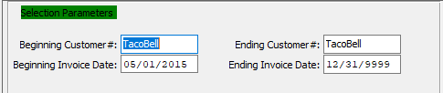

#### Beginning Customer # / Ending Customer #

Enter the beginning and ending Customer Number to run the report for.

#### Beginning Invoice Date / Ending Invoice Date

Enter the beginning and ending Invoice Date to run the report for.

### Available and Selected Columns

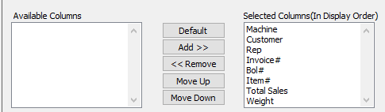

#### Available Columns

The user may choose which columns they wish to have on the report printout. As the user selects their choices, they will appear on the ‘*Selected Columns’* list.

#### Selected Columns (In Display Order)

The columns that the user has chosen from the ‘*Available Columns’* list. The order that these columns are displayed in here is the order in which they will print on the report.

#### Default

Click the ***“Default****”* button to sort the ‘*Selected Columns’* list by the default system parameters.

#### Add >>

Click on the selected item from the ‘*Available Columns’* list to highlight it, then click the ***“Add”*** button to add the selected column to the ‘*Selected Columns’* list.

#### << Remove

Click on the selected item from the ‘*Selected Columns’* list to highlight it, then click the ***“Remove”*** button to remove the selected column to the ‘*Selected Columns’* list.

#### Move Up

Within the ‘*Selected Columns’* list, the user may choose the order they wish the selected columns to print in. In order to change the order of the columns, the user can click on a selection to highlight it. By then clicking the ***“Move Up***” button, the user can change its position on the report.

#### Move Down

Within the ‘*Selected Columns’* list, the user may choose the order they wish the selected columns to print in. In order to change the order of the columns, the user can click on a selection to highlight it. By then clicking the ***“Move Down***” button, the user can change its position on the report.

### Output Destination

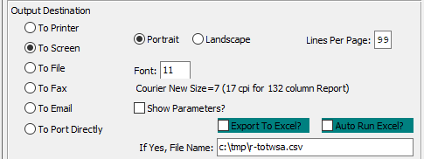

#### Destination Choice

To choose the destination where the document should be printed, please make sure that desired output destination choice bubble is toggled.

#### Layout Choice

To choose the preferred layout of Landscape vs. Portrait, please make sure the desired option choice bubbled is toggled.

#### Lines Per Page

Lines per page on the report when printing.

#### Font

Enter the font number to use with this report (Font 11 is default).

#### Show Parameters? – Toggle Box

To show parameters, make sure that the toggle box is ‘ticked’ with a checkmark.

#### Export to Excel? – Toggle Box

To export the printed file to an excel document, make sure that the Export to Excel toggle box is checked.

#### Auto Run Excel? – Toggle Box

To automatically open the new excel document, make sure that the Auto Run Excel toggle box is checked.

#### If Yes, File Name

If exporting the file to Excel, enter the desired file name.

## Machines MSF Produced by Job [JL4]

### Selection Parameters

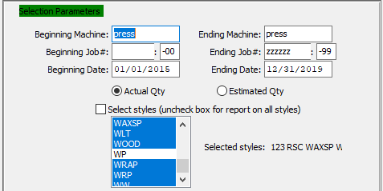

#### Beginning Machine / Ending Machine

Enter the beginning and ending Machine to run the report for.

#### Beginning Job # / Ending Job #

Enter the beginning and ending Job Number to run the report for.

#### Beginning Job #: 00 / Ending Job #: 00

Enter the beginning and ending Subsequent Job Number to run the report for.

#### Beginning Date / Ending Date

Enter the beginning and ending Date to run the report for.

#### Quantity Type (Choice)

To choose the preferred Quantity Type of Actual vs. Estimated, please make sure the desired option choice bubble is toggled.

#### Select Styles (Uncheck Box for Report on All Styles) – Toggle Box

To Select specific Styles for the report, make sure that this toggle box is checked.

#### Selected Styles

If the user has selected to choose specific styles to report on. Click a style to highlight them within the list. The report will only generate for the highlighted styles.

### Available and Selected Columns

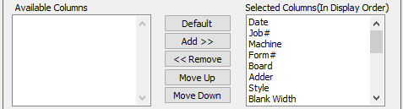

#### Available Columns

The user may choose which columns they wish to have on the report printout. As the user selects their choices, they will appear on the ‘*Selected Columns’* list.

#### Selected Columns (In Display Order)

The columns that the user has chosen from the ‘*Available Columns’* list. The order that these columns are displayed in here is the order in which they will print on the report.

#### Default

Click the ***“Default****”* button to sort the ‘*Selected Columns’* list by the default system parameters.

#### Add >>

Click on the selected item from the ‘*Available Columns’* list to highlight it, then click the ***“Add”*** button to add the selected column to the ‘*Selected Columns’* list.

#### << Remove

Click on the selected item from the ‘*Selected Columns’* list to highlight it, then click the ***“Remove”*** button to remove the selected column to the ‘*Selected Columns’* list.

#### Move Up

Within the ‘*Selected Columns’* list, the user may choose the order they wish the selected columns to print in. In order to change the order of the columns, the user can click on a selection to highlight it. By then clicking the ***“Move Up***” button, the user can change its position on the report.

#### Move Down

Within the ‘*Selected Columns’* list, the user may choose the order they wish the selected columns to print in. In order to change the order of the columns, the user can click on a selection to highlight it. By then clicking the ***“Move Down***” button, the user can change its position on the report.

### Output Destination

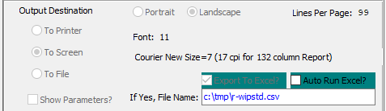

#### Destination Choice

To choose the destination where the document should be printed, please make sure that desired output destination choice bubble is toggled.

#### Layout Choice

To choose the preferred layout of Landscape vs. Portrait, please make sure the desired option choice bubbled is toggled.

#### Lines Per Page

Lines per page on the report when printing.

#### Font

Enter the font number to use with this report (Font 11 is default).

#### Show Parameters? – Toggle Box

To show parameters, make sure that the toggle box is ‘ticked’ with a checkmark.

#### Export to Excel? – Toggle Box

To export the printed file to an excel document, make sure that the Export to Excel toggle box is checked.

#### Auto Run Excel? – Toggle Box

To automatically open the new excel document, make sure that the Auto Run Excel toggle box is checked.

#### If Yes, File Name

If exporting the file to Excel, enter the desired file name.

## Prep Charge Report [JL5]

### Selection Parameters

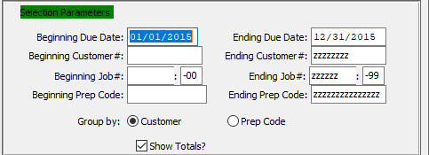

#### Beginning Due Date / Ending Due Date

Enter the beginning and ending Due Date to run the report for.

#### Beginning Customer # / Ending Customer #

Enter the beginning and ending Customer Number to run the report for.

#### Beginning Job # / Ending Job #

Enter the beginning and ending Job Number to run the report for.

#### Beginning Job #: 00 / Ending Job #: 00

Enter the beginning and ending Subsequent Job Number to run the report for.

#### Beginning Prep Code / Ending Prep Code

Enter the beginning and ending Prep Code to run the report for.

#### Group By (Choice)

To choose the preferred grouping of Customer vs. Prep Code, please make sure the desired option choice bubble is toggled.

#### Show Totals? – Toggle Box

To show totals on the Prep Charge Report, make sure that the Show Totals toggle box is checked.

### Available and Selected Columns

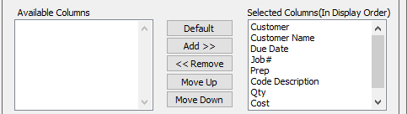

#### Available Columns

The user may choose which columns they wish to have on the report printout. As the user selects their choices, they will appear on the ‘*Selected Columns’* list.

#### Selected Columns (In Display Order)

The columns that the user has chosen from the ‘*Available Columns’* list. The order that these columns are displayed in here is the order in which they will print on the report.

#### Default

Click the ***“Default****”* button to sort the ‘*Selected Columns’* list by the default system parameters.

#### Add >>

Click on the selected item from the ‘*Available Columns’* list to highlight it, then click the ***“Add”*** button to add the selected column to the ‘*Selected Columns’* list.

#### << Remove

Click on the selected item from the ‘*Selected Columns’* list to highlight it, then click the ***“Remove”*** button to remove the selected column to the ‘*Selected Columns’* list.

#### Move Up

Within the ‘*Selected Columns’* list, the user may choose the order they wish the selected columns to print in. In order to change the order of the columns, the user can click on a selection to highlight it. By then clicking the ***“Move Up***” button, the user can change its position on the report.

#### Move Down

Within the ‘*Selected Columns’* list, the user may choose the order they wish the selected columns to print in. In order to change the order of the columns, the user can click on a selection to highlight it. By then clicking the ***“Move Down***” button, the user can change its position on the report.

### Output Destination

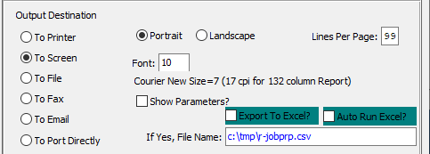

#### Destination Choice

To choose the destination where the document should be printed, please make sure that desired output destination choice bubble is toggled.

#### Layout Choice

To choose the preferred layout of Landscape vs. Portrait, please make sure the desired option choice bubbled is toggled.

#### Lines Per Page

Lines per page on the report when printing.

#### Font

Enter the font number to use with this report (Font 11 is default).

#### Show Parameters? – Toggle Box

To show parameters, make sure that the toggle box is ‘ticked’ with a checkmark.

#### Export to Excel? – Toggle Box

To export the printed file to an excel document, make sure that the Export to Excel toggle box is checked.

#### Auto Run Excel? – Toggle Box

To automatically open the new excel document, make sure that the Auto Run Excel toggle box is checked.

#### If Yes, File Name

If exporting the file to Excel, enter the desired file name.

## Job Actual Cost Detail [JL6]

### Selection Parameters

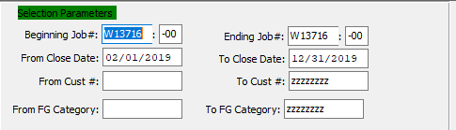

#### Beginning Job # / Ending Job #

Enter the beginning and ending Job Number to run the report for.

#### Beginning Job #: 00 / Ending Job #: 00

Enter the beginning and ending Subsequent Job Number to run the report for.

#### Beginning Close Date / Ending Close Date

Enter the beginning and ending Close Date to run the report for.

#### Beginning Customer # / Ending Customer #

Enter the beginning and ending Customer Number to run the report for.

#### Beginning FG Category / Ending FG Category

Enter the beginning and ending Finished Good Category to run the report for.

### Available and Selected Columns

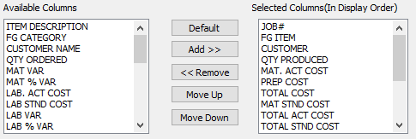

#### Available Columns

The user may choose which columns they wish to have on the report printout. As the user selects their choices, they will appear on the ‘*Selected Columns’* list.

#### Selected Columns (In Display Order)

The columns that the user has chosen from the ‘*Available Columns’* list. The order that these columns are displayed in here is the order in which they will print on the report.

#### Default

Click the ***“Default****”* button to sort the ‘*Selected Columns’* list by the default system parameters.

#### Add >>

Click on the selected item from the ‘*Available Columns’* list to highlight it, then click the ***“Add”*** button to add the selected column to the ‘*Selected Columns’* list.

#### << Remove

Click on the selected item from the ‘*Selected Columns’* list to highlight it, then click the ***“Remove”*** button to remove the selected column to the ‘*Selected Columns’* list.

#### Move Up

Within the ‘*Selected Columns’* list, the user may choose the order they wish the selected columns to print in. In order to change the order of the columns, the user can click on a selection to highlight it. By then clicking the ***“Move Up***” button, the user can change its position on the report.

#### Move Down

Within the ‘*Selected Columns’* list, the user may choose the order they wish the selected columns to print in. In order to change the order of the columns, the user can click on a selection to highlight it. By then clicking the ***“Move Down***” button, the user can change its position on the report.

### Output Destination

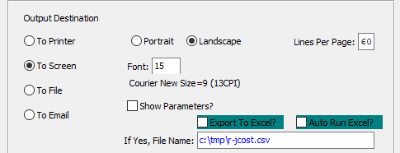

#### Destination Choice

To choose the destination where the document should be printed, please make sure that desired output destination choice bubble is toggled.

#### Layout Choice

To choose the preferred layout of Landscape vs. Portrait, please make sure the desired option choice bubbled is toggled.

#### Font

Enter the font number to use with this report (Font 11 is default).

#### Show Parameters? – Toggle Box

To show parameters, make sure that the toggle box is ‘ticked’ with a checkmark.

#### Export to Excel? – Toggle Box

To export the printed file to an excel document, make sure that the Export to Excel toggle box is checked.

#### Auto Run Excel? – Toggle Box

To automatically open the new excel document, make sure that the Auto Run Excel toggle box is checked.

#### If Yes, File Name

If exporting the file to Excel, enter the desired file name.

## WIP Value of Sheeted Inventory [JL7]

### Selection Parameters

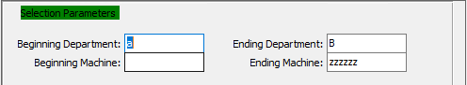

#### Beginning Department / Ending Department

Enter the beginning and ending Department to run the report for.

#### Beginning Machine / Ending Machine

Enter the beginning and ending Machine to run the report for.

### Available and Selected Columns

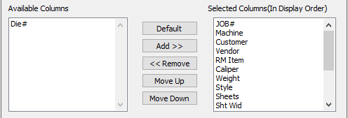

#### Available Columns

The user may choose which columns they wish to have on the report printout. As the user selects their choices, they will appear on the ‘*Selected Columns’* list.

#### Selected Columns (In Display Order)

The columns that the user has chosen from the ‘*Available Columns’* list. The order that these columns are displayed in here is the order in which they will print on the report.

#### Default

Click the ***“Default****”* button to sort the ‘*Selected Columns’* list by the default system parameters.

#### Add >>

Click on the selected item from the ‘*Available Columns’* list to highlight it, then click the ***“Add”*** button to add the selected column to the ‘*Selected Columns’* list.

#### << Remove

Click on the selected item from the ‘*Selected Columns’* list to highlight it, then click the ***“Remove”*** button to remove the selected column to the ‘*Selected Columns’* list.

#### Move Up

Within the ‘*Selected Columns’* list, the user may choose the order they wish the selected columns to print in. In order to change the order of the columns, the user can click on a selection to highlight it. By then clicking the ***“Move Up***” button, the user can change its position on the report.

#### Move Down

Within the ‘*Selected Columns’* list, the user may choose the order they wish the selected columns to print in. In order to change the order of the columns, the user can click on a selection to highlight it. By then clicking the ***“Move Down***” button, the user can change its position on the report.

### Output Destination

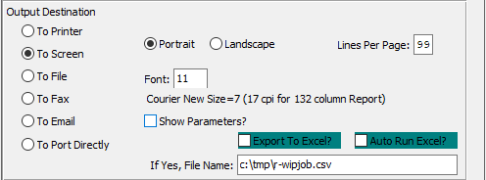

#### Destination Choice

To choose the destination where the document should be printed, please make sure that desired output destination choice bubble is toggled.

#### Layout Choice

To choose the preferred layout of Landscape vs. Portrait, please make sure the desired option choice bubbled is toggled.

#### Lines Per Page

Lines per page on the report when printing.

#### Font

Enter the font number to use with this report (Font 11 is default).

#### Show Parameters? – Toggle Box

To show parameters, make sure that the toggle box is ‘ticked’ with a checkmark.

#### Export to Excel? – Toggle Box

To export the printed file to an excel document, make sure that the Export to Excel toggle box is checked.

#### Auto Run Excel? – Toggle Box

To automatically open the new excel document, make sure that the Auto Run Excel toggle box is checked.

#### If Yes, File Name

If exporting the file to Excel, enter the desired file name.

## Estimated Job Cost Detail [JL8]

### Selection Parameters

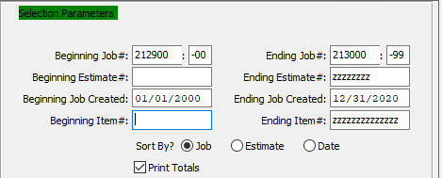

#### Beginning Job # / Ending Job #

Enter the beginning and ending Job Number to run the report for.

#### Beginning Job #: 00 / Ending Job #: 00

Enter the beginning and ending Subsequent Job Number to run the report for.

#### Beginning Estimate # / Ending Estimate #

Enter the beginning and ending Estimate Number to run the report for.

#### Beginning Job Created Date / Ending Job Created Date

Enter the beginning and ending Job Created Date to run the report for.

#### Beginning Item # / Ending Item #

Enter the beginning and ending Item Number to run the report for.

#### Sort By? (Choice)

To choose the preferred sorting method of Job vs. Estimate vs. Date, please make sure the desired option choice bubble is toggled.

#### Print Totals? – Toggle Box

To print totals on the detailed report, make sure that the Print Totals toggle box is checked.

### Available and Selected Columns

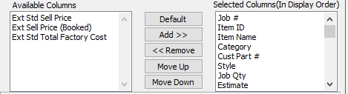

#### Available Columns

The user may choose which columns they wish to have on the report printout. As the user selects their choices, they will appear on the ‘*Selected Columns’* list.

#### Selected Columns (In Display Order)

The columns that the user has chosen from the ‘*Available Columns’* list. The order that these columns are displayed in here is the order in which they will print on the report.

#### Default

Click the ***“Default****”* button to sort the ‘*Selected Columns’* list by the default system parameters.

#### Add >>

Click on the selected item from the ‘*Available Columns’* list to highlight it, then click the ***“Add”*** button to add the selected column to the ‘*Selected Columns’* list.

#### << Remove

Click on the selected item from the ‘*Selected Columns’* list to highlight it, then click the ***“Remove”*** button to remove the selected column to the ‘*Selected Columns’* list.

#### Move Up

Within the ‘*Selected Columns’* list, the user may choose the order they wish the selected columns to print in. In order to change the order of the columns, the user can click on a selection to highlight it. By then clicking the ***“Move Up***” button, the user can change its position on the report.

#### Move Down

Within the ‘*Selected Columns’* list, the user may choose the order they wish the selected columns to print in. In order to change the order of the columns, the user can click on a selection to highlight it. By then clicking the ***“Move Down***” button, the user can change its position on the report.

### Output Destination

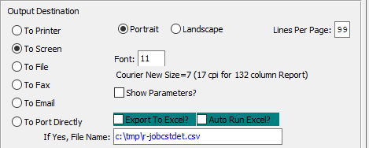

#### Destination Choice

To choose the destination where the document should be printed, please make sure that desired output destination choice bubble is toggled.

#### Layout Choice

To choose the preferred layout of Landscape vs. Portrait, please make sure the desired option choice bubbled is toggled.

#### Lines Per Page

Lines per page on the report when printing.

#### Font

Enter the font number to use with this report (Font 11 is default).

#### Show Parameters? – Toggle Box

To show parameters, make sure that the toggle box is ‘ticked’ with a checkmark.

#### Export to Excel? – Toggle Box

To export the printed file to an excel document, make sure that the Export to Excel toggle box is checked.

#### Auto Run Excel? – Toggle Box

To automatically open the new excel document, make sure that the Auto Run Excel toggle box is checked.

#### If Yes, File Name

If exporting the file to Excel, enter the desired file name.

## Print FG Labels [JL9]

### Selection Parameters

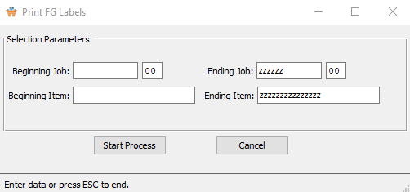

#### Beginning Job # / Ending Job #

Enter the beginning and ending Job Number to Print Finished Good Labels for.

#### Beginning Job #: 00 / Ending Job #: 00

Enter the beginning and ending Subsequent Job Number to Print Finished Good Labels for.

#### Beginning Item / Ending Item

Enter the beginning and ending Item to Print Finished Good Labels for.

# **File Maintenance for Jobs [JF]**

The Job Costing File Maintenance programs must first be created prior to utilizing the Job Costing system. The Machine Charge Codes provides categories for posting machine and labor operations which may be broken down to down time chargeable to a job, downtime not chargeable to a job, make ready and run.

The Job Costing Control File allows company defined parameters for posting materials and other controls. The Product Line G/L Account maintains all of the General Ledger account numbers for Work in Process, Finished Goods, Cost of Goods Sold, Actual Material Expenses and Variances.

## Machine Charge Codes [JF1]

### Overview

The Machine Charge Codes are user definable codes which allow your company to provide reporting for various Down Time, Run and Make Ready categories for each machine. There are four valid categories for each charge code that your company defines. Within these four categories there may be unlimited codes to break down each category.

Valid Categories are as Follows

|  |  |  |  |
| --- | --- | --- | --- |
| DT | Down Time (Chargeable to Job) | NC | Not Down Time Chargeable |
| MR | Make Ready | Run | Production Running |

The user may create as many Charge Codes within each category. The benefit of creating multiple categories is that reports will print by the charge code for machine analysis purposes.

For example, you may print down time due to Warped Board or Electrical reasons to evaluate a particular board vendor or the efficiency or maintenance requirements of a machine.

### Browse Codes

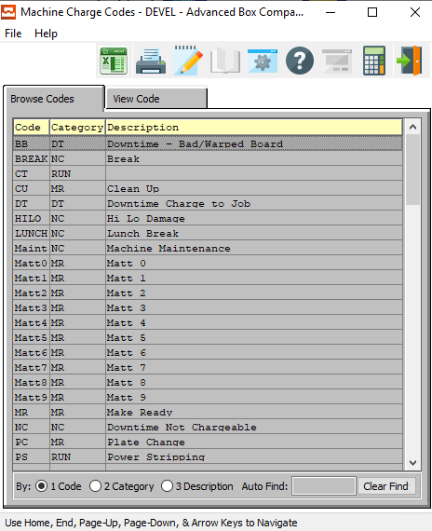

### View Code

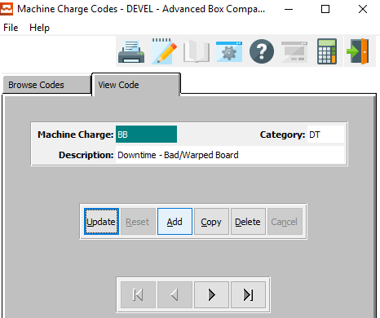

#### UPDATE

To change the currently selected Code, simply click the ***“Update***” button at the bottom of the screen.

#### ADD

Click the ***“Add”*** button to add a new Code.

#### COPY

Click the ***“Copy”*** button to copy information from the currently selected Code.

#### DELETE

To delete the currently selected Code, simply press the ***"D"*** key. Alternatively, click the ***“Delete”*** button at the bottom of the screen.

#### NEXT

Press ***"N"*** (Next) to find next Code to view or modify. Alternatively, press the ***“Right Arrow”*** on the screen.

#### PREVIOUS

Press ***"P"*** (Previous) to find previous Code to view or modify. Alternatively, press the ***“Left Arrow”*** on the screen.

### Add/Update Code

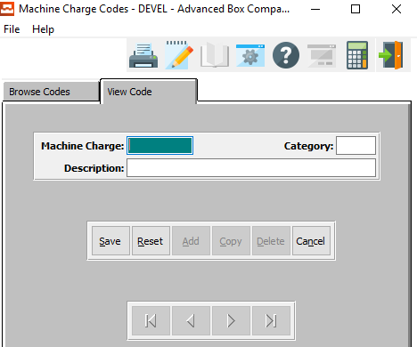

#### SAVE

Click the ***“Save”*** button to save all changes to the current Code.

#### RESET

Click the ***“Reset”*** button to reset all fields to their original state.

#### CANCEL

Click the ***“Cancel”*** button to cancel all changes to the Code without saving.

### Add/Update Code Field Definitions

#### Machine Charge

The code is a user defined code which will be used when posting labor through production. Examples are DT, Warped Board, DT Electrical, DT No Work, etc. Reports will print by the charge code so that management may review a particular machine to see what types of maintenance problems or efficiency by a particular charge code.

#### Category

Valid Categories are as Follows

|  |  |  |  |
| --- | --- | --- | --- |
| DT | Down Time (Chargeable to Job) | NC | Not Down Time Chargeable |
| MR | Make Ready | Run | Production Running |

#### Description

Each description for each code entered may be defined by your company.

## Job Cost Control [JF2]

### Overview

The Job Costing Control File defines material types used on a job to post the actual cost of these materials at the estimated cost. If the flag is set to *‘yes’*, the cost defined in the Job Costing file which comes from the Estimate will be utilized to post as an actual cost to the work in process General Ledger accounts. This is useful to save many hours of data entry time for materials which are considered insignificant in cost.

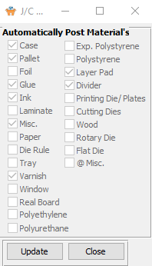

#### UPDATE

To change the currently selected XXX, simply click the ***“Update***” button at the bottom of the screen.

#### CLOSE

Click the ***“Close”*** button to exit the Control popup screen.

### Update Job Cost Control

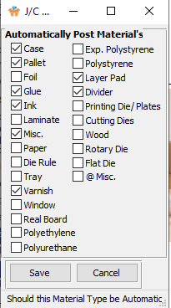

#### SAVE

Click the ***“Save”*** button to save all changes to the Job Cost Control.

#### CANCEL

Click the ***“Cancel”*** button to cancel all changes to the Job Cost Control without saving.

### Update Job Cost Control Field Definitions

#### Automatically Post Materials

Each toggle box here represents a specific material. If the toggle box is check marked, the material it represents automatically post when it is added to a job, thus saving the user time on items that might be used most often.

## Product Line GL Accounts [JF3]

### Overview

The product line file allows your company to define a General Ledger account for Work in Process, Finished Goods Assets Accounts, Costs of Goods Sold, and Actual Applied costs broken down between material, direct labor, fixed overhead and variable overhead. Multiple product categories may be assigned to a product line and multiple product lines may be defined for your company. Each product line will produce a profit and loss statement for your company.

The Product Category which is defined for an item in both the Finished Goods file and the Estimate must be defined for each Product Line so that the system knows which General Ledger accounts to use when an item is received into inventory or invoiced.

For example, we may have a product line simply called FC for Folding Cartons. However, we may have multiple categories breaking down Folding Cartons by cosmetic, pharmaceutical, candy, hardware, etc. As an alternative we may want to define each category as a product line to get profit and loss reporting for each category.

Please Note: Under this last scenario, multiple General Ledger numbers are required for each product line.

### Browse Product Lines

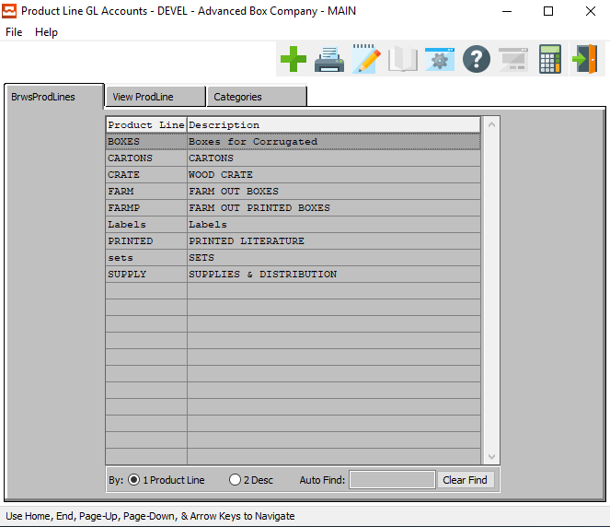

#### ADD

Click the ***“Green + Icon”*** to add a new Product Line.

### View Product Line

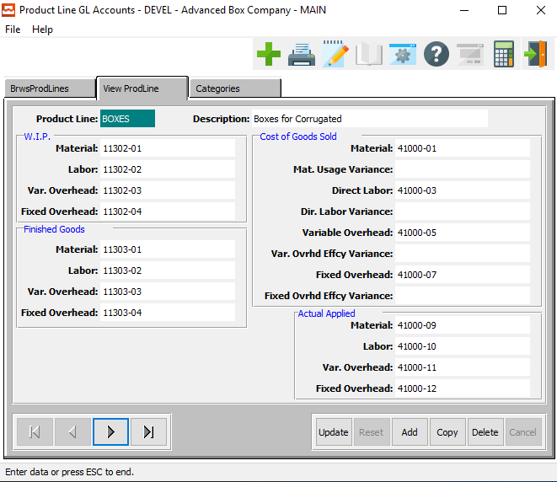

#### UPDATE

To change the currently selected Product Line, simply click the ***“Update***” button at the bottom of the screen.

#### ADD

To add a new Product Line, simply click the ***“Green + Icon”*** button at the top of the Product Line screen.

#### DELETE

To delete the currently selected Product Line, simply press the ***"D"*** key. Alternatively, click the ***“Delete”*** button at the bottom of the screen.

#### NEXT

Press ***"N"*** (Next) to find next Product Line to view or modify. Alternatively, press the ***“Right Arrow”*** on the screen.

#### PREVIOUS

Press ***"P"*** (Previous) to find previous Product Line to view or modify. Alternatively, press the ***“Left Arrow”*** on the screen.

### Add/Update Product Line

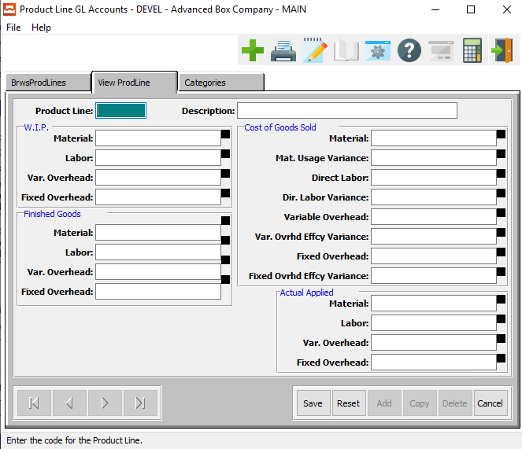

#### SAVE

Click the ***“Save”*** button to save all changes to the current Product Line.

#### RESET

Click the ***“Reset”*** button to reset all fields to their original state.

#### CANCEL

Click the ***“Cancel”*** button to cancel all changes to the Product Line without saving.

### Add/Update Product Line Field Definitions

#### Product Line

The product line is a user defined code which will dictate all of the GL accounts to be used when processing a job. When posting costs to an item on a job, the product category will be searched to find a product line. Once the product line is found, the system will know which GL accounts to use for issuing material, posting labor, and Finished Goods.

#### Description

The description is user definable and may be as simple as Finished Goods or you may break down the description for the product line into different lines such as Cosmetic, Pharmaceutical, etc.

#### W.I.P. Material

Enter a valid General Ledger account for Work in Process materials. This will be used to debit and credit Work In Process material.

#### W.I.P. Labor

Enter a valid General Ledger account for Work in Process Direct Labor. This will be used to debit and credit Work in Process direct labor.

#### W.I.P Variable Overhead

Enter a valid General Ledger account for Work in Process Variable Overhead. This will be used to debit and credit Work in Process Variable Overhead.

#### W.I.P. Fixed Overhead

Enter a valid General Ledger account for Work in Process Fixed Overhead. This will be used to debit and credit Work in Process Fixed Overhead.

#### Finished Goods: Material

Enter a valid General Ledger account for Finished Goods Material. This will be used to debit and credit Finished Goods Materials.

#### Finished Goods: Labor

Enter a valid General Ledger account for Finished Goods Direct Labor. This will be used to debit and credit Finished Goods Direct Labor.

#### Finished Goods: Variable Overhead

Enter a valid General Ledger account for Finished Goods Variable Overhead. This will be used to debit and credit Finished Goods Variable Overhead.

#### Finished Goods: Fixed Overhead

Enter a valid General Ledger account for Finished Goods Fixed Overhead. This will be used to debit and credit Finished Goods Fixed Overhead.

#### Cost of Goods Sold: Material

Enter a valid General Ledger account for Cost of Goods Sold Material. This will be used to debit and credit Cost of Goods Sold Material.

#### Cost of Goods Sold: Material Usage Variance

Enter a valid General Ledger account for Cost of Goods Sold Material Usage Variance. This will be used to debit and credit Cost of Goods Sold Material Usage Variance.

#### Cost of Goods Sold: Direct Labor

Enter a valid General Ledger account for Cost of Goods Sold Direct Labor. This will be used to debit and credit Cost of Goods Sold Direct Labor.

#### Cost of Goods Sold: Direct Labor Variance

Enter a valid General Ledger account for Costs of Goods Sold Direct Labor Variance. This will be used to debit and credit Cost of Goods Sold Direct Labor Variance.

#### Cost of Goods Sold: Variable Overhead

Enter a valid General Ledger account for Cost of Goods Sold Variable Overhead. This will be used to debit and credit Cost of Goods Sold Variable Overhead.

#### Cost of Goods Sold: Variable Overhead Efficiency Variance

Enter a valid General Ledger account for Cost of Goods Sold Variable Overhead Efficiency Variance. This will be used to debit and credit Cost of Goods Sold Variable Overhead Efficiency Variance.

#### Cost of Goods Sold: Fixed Overhead

Enter a valid General Ledger account for Cost of Goods Sold Fixed Overhead. This will be used to debit and credit Cost of Goods Sold Fixed Overhead.

#### Cost of Goods Sold: Fixed Overhead Efficiency Variance

Enter a valid General Ledger account for Cost of Goods Sold Fixed Overhead Efficiency Variance. This will be used to debit and credit Cost of Goods Sold Fixed Overhead Efficiency Variance.

#### Actual Applied: Material

Enter a valid General Ledger account for Actual Applied Materials. This will be used to debit and credit Actual Applied Materials.

#### Actual Applied: Labor

Enter a valid General Ledger account for Actual Applied Direct Labor. This will be used to debit and credit Actual Applied Direct Labor.

#### Actual Applied: Variable Overhead

Enter a valid General Ledger account for Actual Applied Variable Overhead. This will be used to debit and credit Actual Applied Variable Overhead.

#### Actual Applied: Fixed Overhead

Enter a valid General Ledger account for Actual Applied Fixed Overhead. This will be used to debit and credit Actual Applied Fixed Overhead.

### Categories

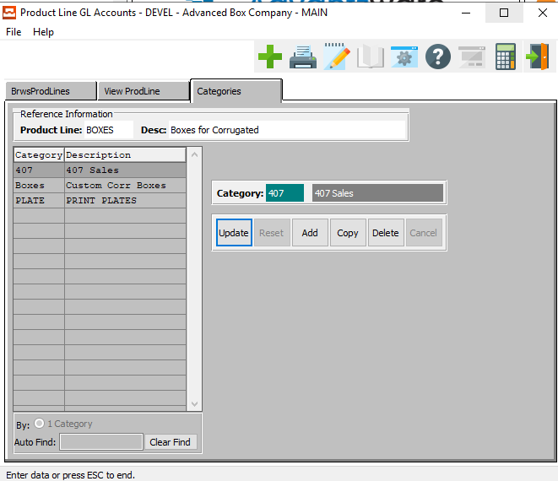

#### UPDATE

To change the currently selected Category, simply click the ***“Update***” button at the bottom of the screen.

#### ADD

Click the ***“Add”*** button to add a new Category.

#### COPY

Click the ***“Copy”*** button to copy information from the currently selected Category.

#### DELETE

To delete the currently selected Category, simply press the ***"D"*** key. Alternatively, click the ***“Delete”*** button at the bottom of the screen.

### Add/Update Categories

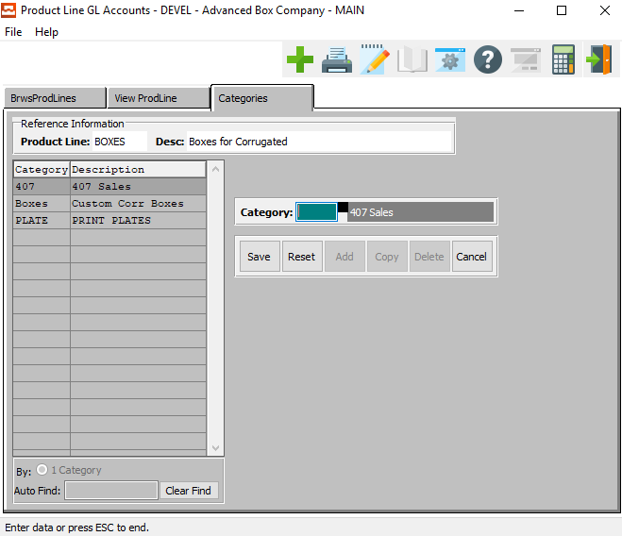

#### SAVE

Click the ***“Save”*** button to save all changes to the current Category.

#### RESET

Click the ***“Reset”*** button to reset all fields to their original state.

#### CANCEL

Click the ***“Cancel”*** button to cancel all changes to the Category without saving.

#### Category

Enter a valid category for this product.

## Job Hold Reasons [JF6]

### Browse Reason

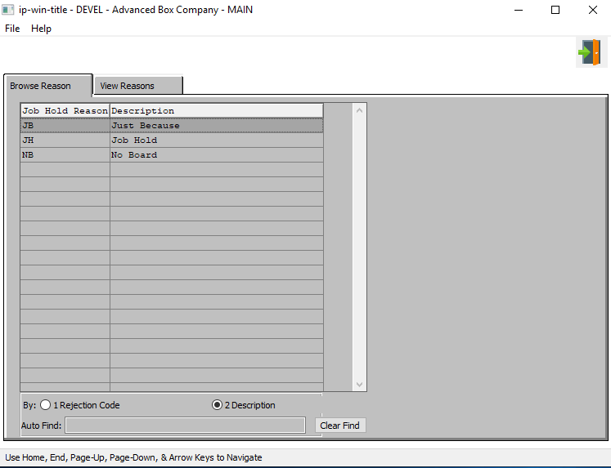

#### EXIT

Click the ***“Exit Door Icon”*** to exit the Job Hold Reasons popup screen.

### View Reasons

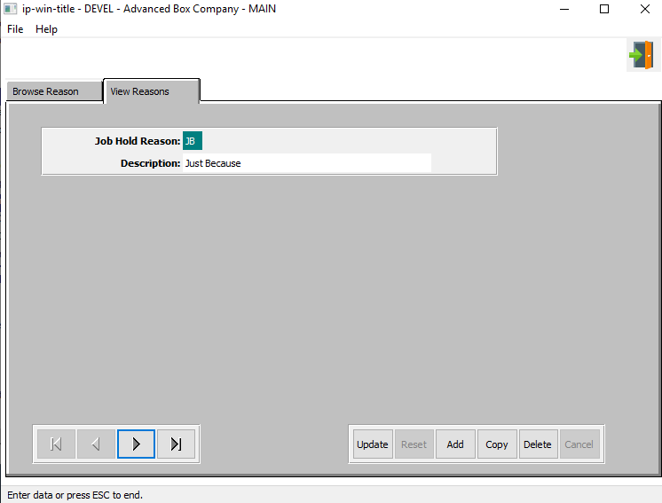

#### UPDATE

To change the currently selected Job Hold Reason, simply click the ***“Update***” button at the bottom of the screen.

#### ADD

Click the ***“Add”*** button to add a new Job Hold Reason.

#### DELETE

To delete the currently selected Job Hold Reason, simply press the ***"D"*** key. Alternatively, click the ***“Delete”*** button at the bottom of the screen.

#### NEXT

Press ***"N"*** (Next) to find next Job Hold Reason to view or modify. Alternatively, press the ***“Right Arrow”*** on the screen.

#### PREVIOUS

Press ***"P"*** (Previous) to find previous Job Hold Reason to view or modify. Alternatively, press the ***“Left Arrow”*** on the screen.

#### EXIT

Click the ***“Exit Door Icon”*** to exit the Job Hold Reason popup screen.

### Add/Update Reasons

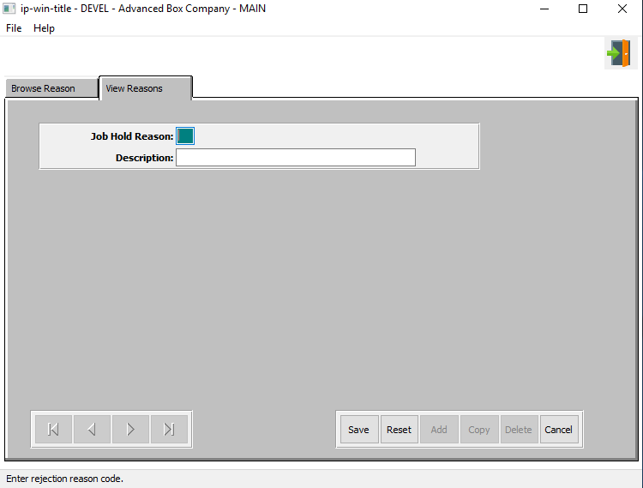

#### SAVE

Click the ***“Save”*** button to save all changes to the current Job Hold Reason.

#### RESET

Click the ***“Reset”*** button to reset all fields to their original state.

#### CANCEL

Click the ***“Cancel”*** button to cancel all changes to the Job Hold Reason without saving.

#### EXIT

Click the ***“Exit Door Icon”*** to exit the Job Hold Reason popup screen.

### Add/Update Reasons Field Definitions

#### Job Hold Reason

The user may enter a two-letter code to represent the reason they are creating.

#### Description

The user may enter a short description of the job hold reason they are creating here.